CLOUD COMPUTING

Building Decoupled Applications by Using Amazon SQS

**Task 1: Installing the Image Processing Application**

**1.1 Logging in to AWS Cloud9 IDE**

* You access the Cloud9 IDE using a provided URL and disable temporary AWS credentials to allow usage of IAM roles.

**1.2 Downloading Files and Installing the App**

* Download the source code (code.zip), unzip it, and install required Node.js modules for the **web server** and **application server** using npm install.

**1.3 Configuring Security Group and IAM Role**

* **Security Group**: Opens ports 8000–8100 for traffic.
* **IAM Role**: Assigns a role with necessary AWS permissions to EC2 instances Phase1Server and Phase2Server.

**1.4 Configuring S3 Bucket Permissions**

* **Unblock public access** to the S3 bucket and set a **bucket policy** to allow access only from your local IP.

**1.5 Configuring and Starting the App**

* You edit three config files:
  + **Browser** (config.js)
  + **Web server** (libs/config.js)
  + **App server** (libs/config.js)
* Replace placeholders with actual values like public IP and bucket name.
* Start both servers (npm start) on ports **8008** (web) and **8009** (app).

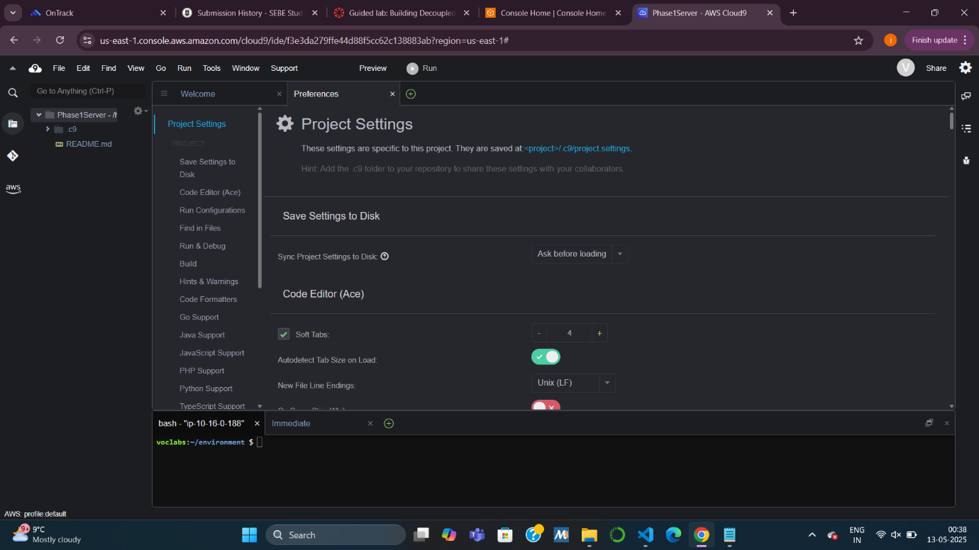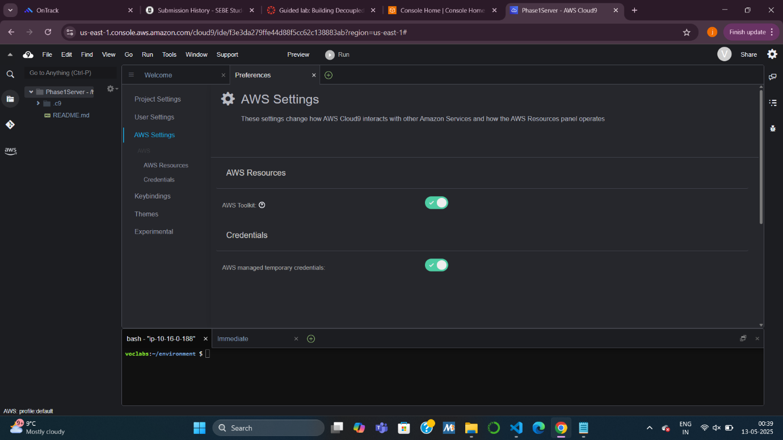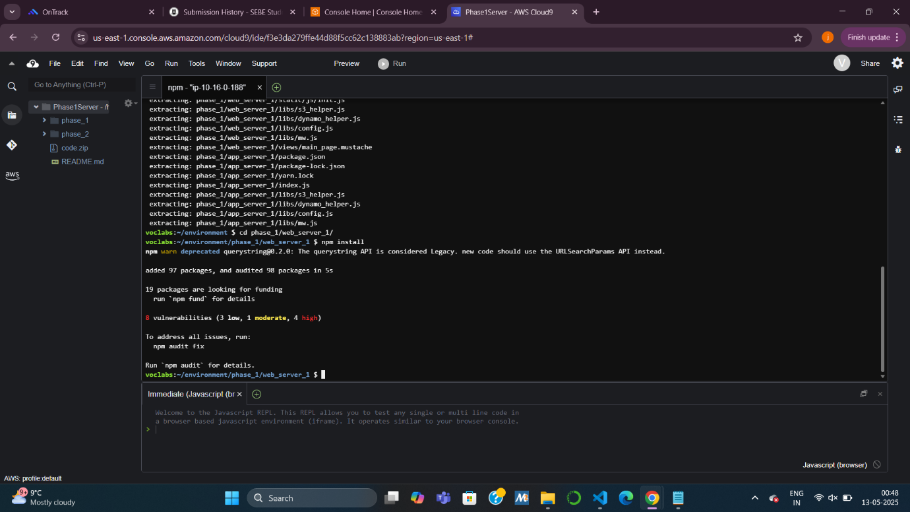

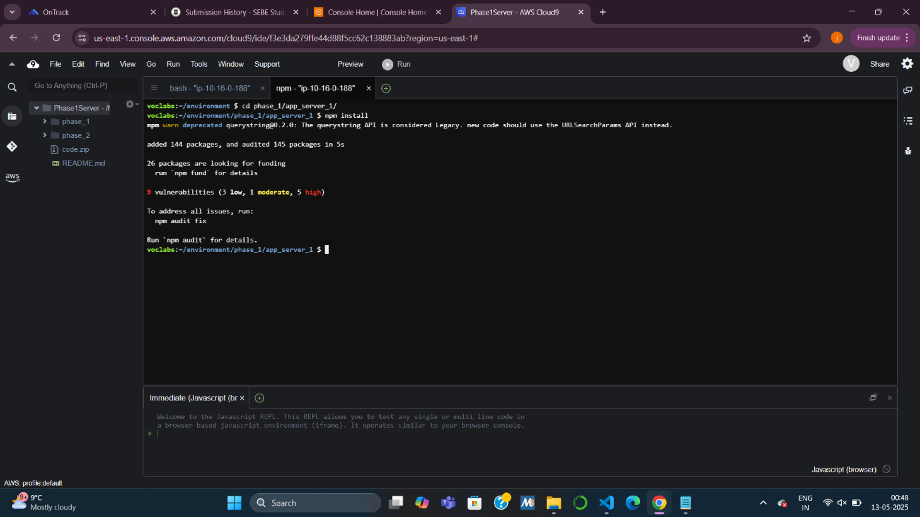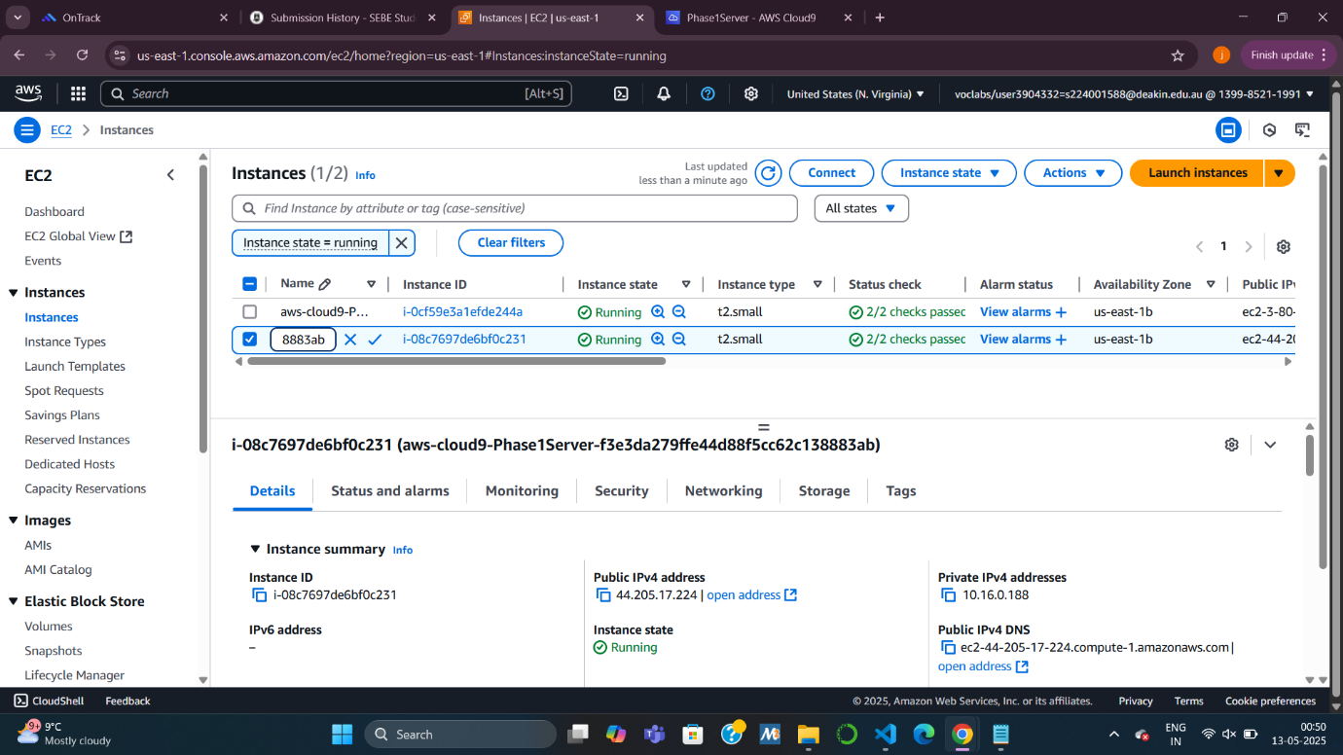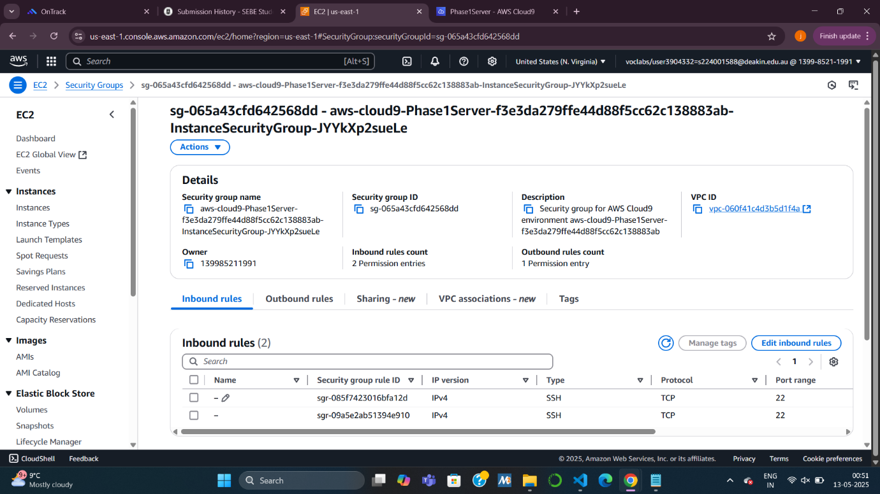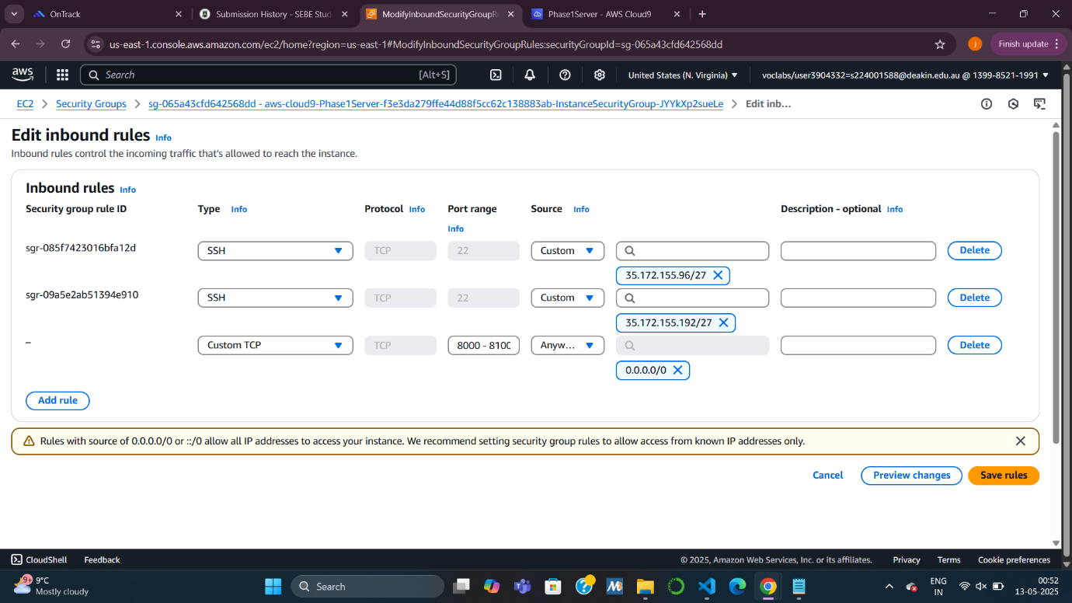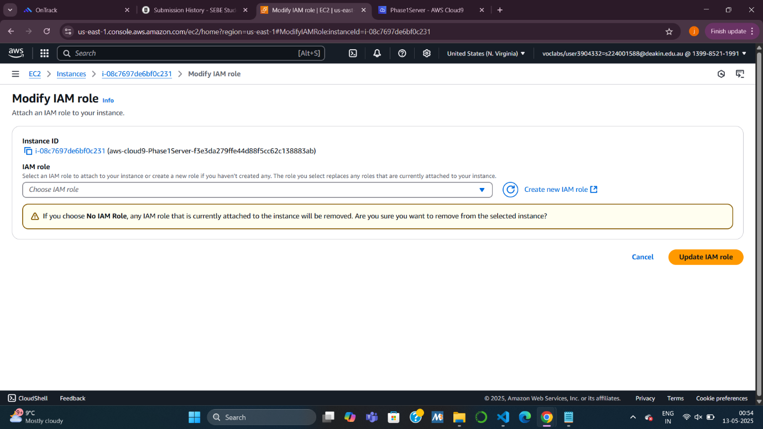

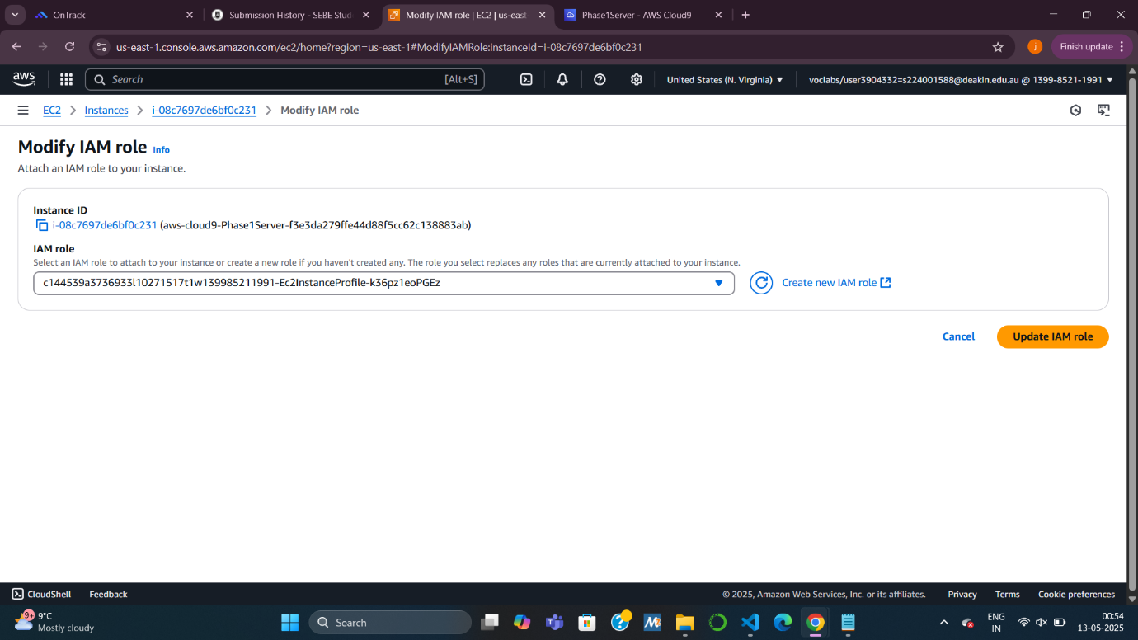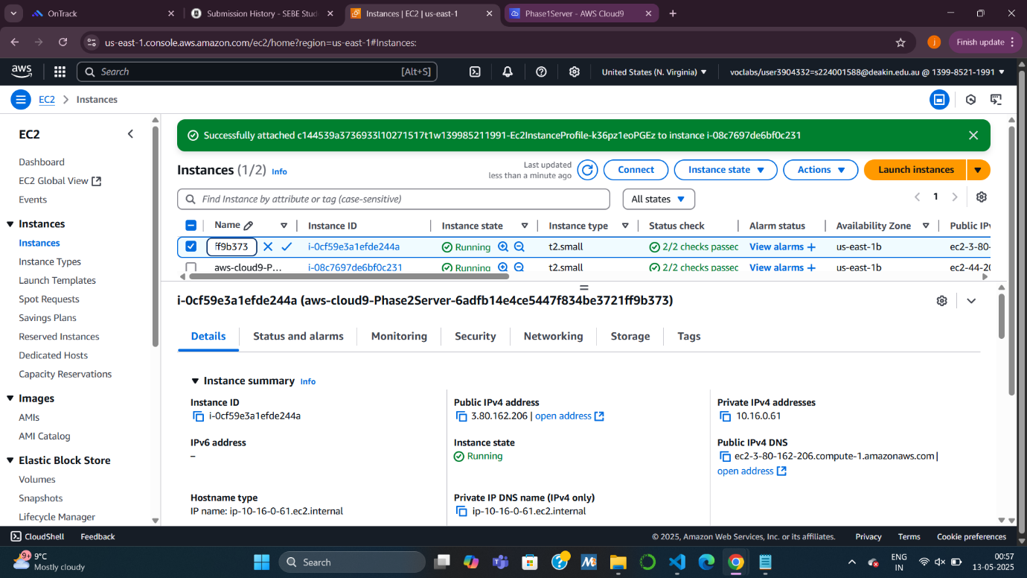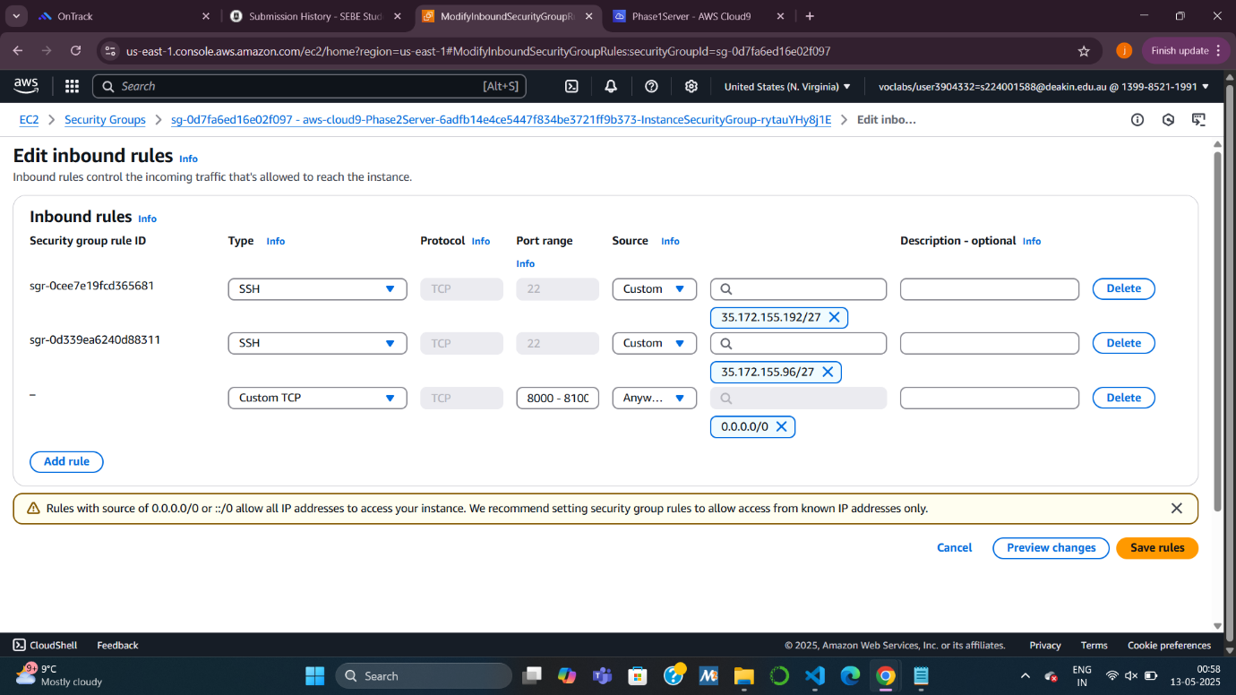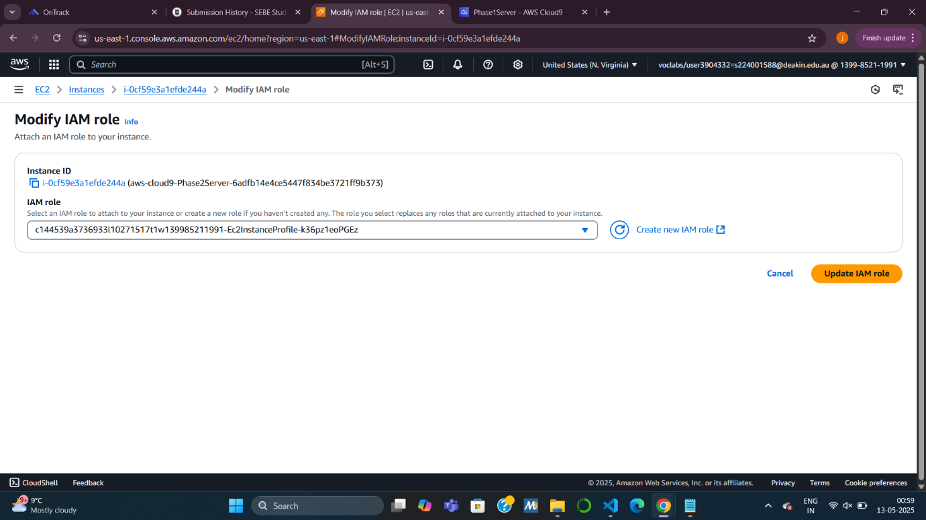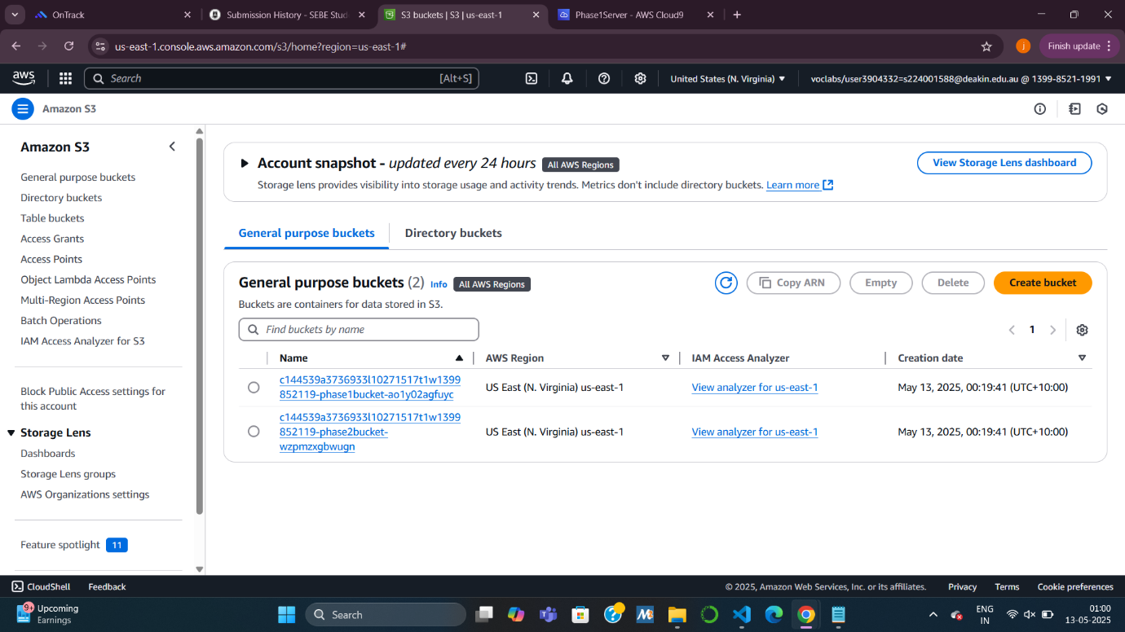

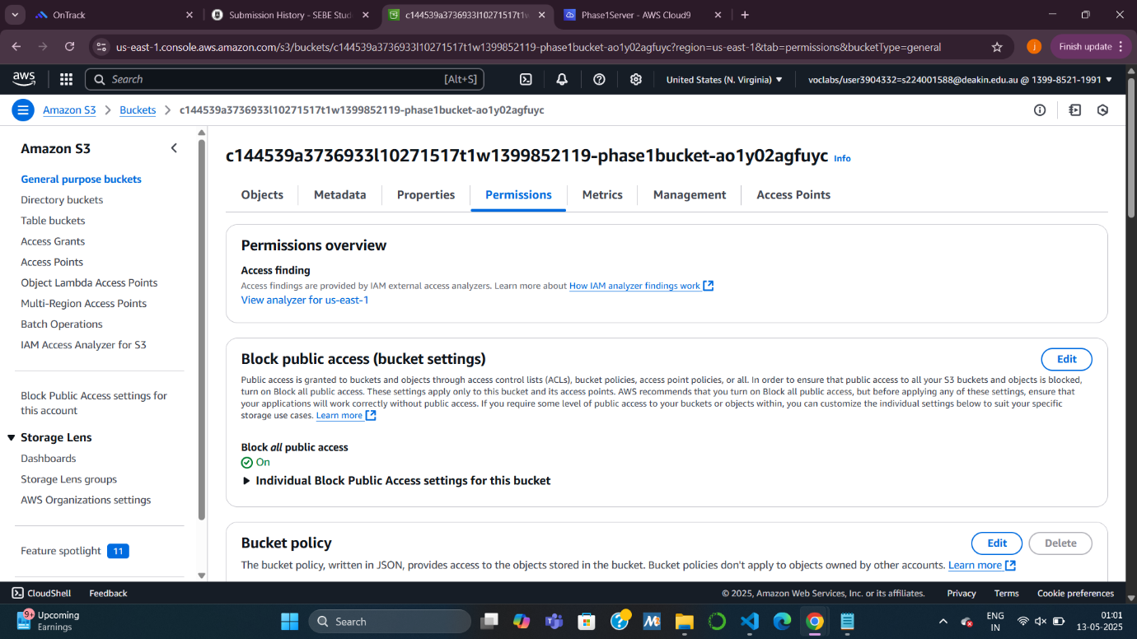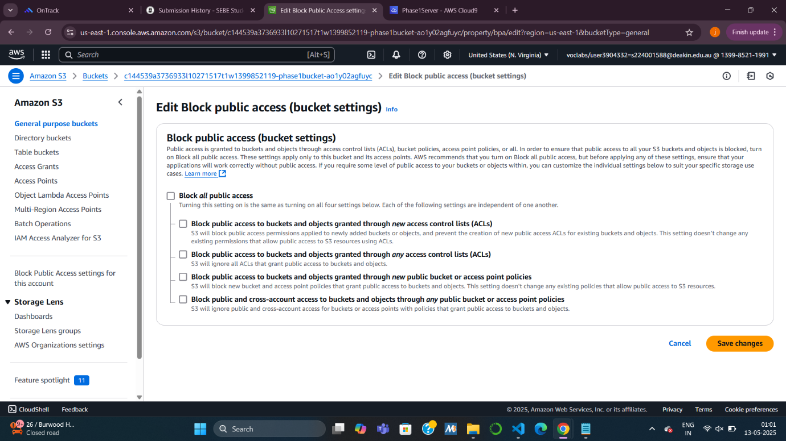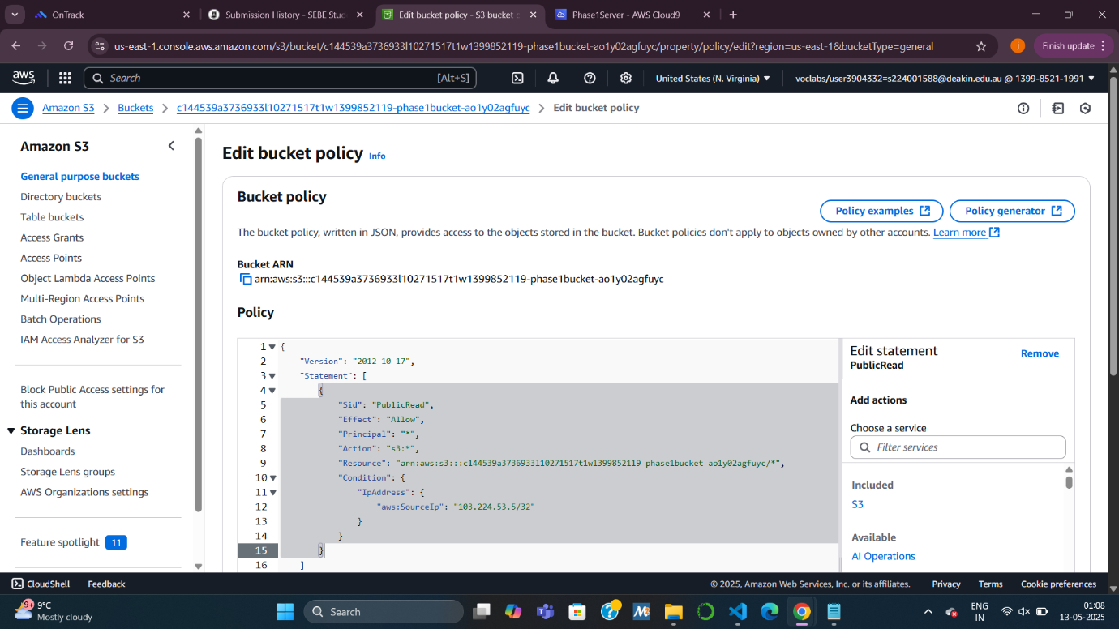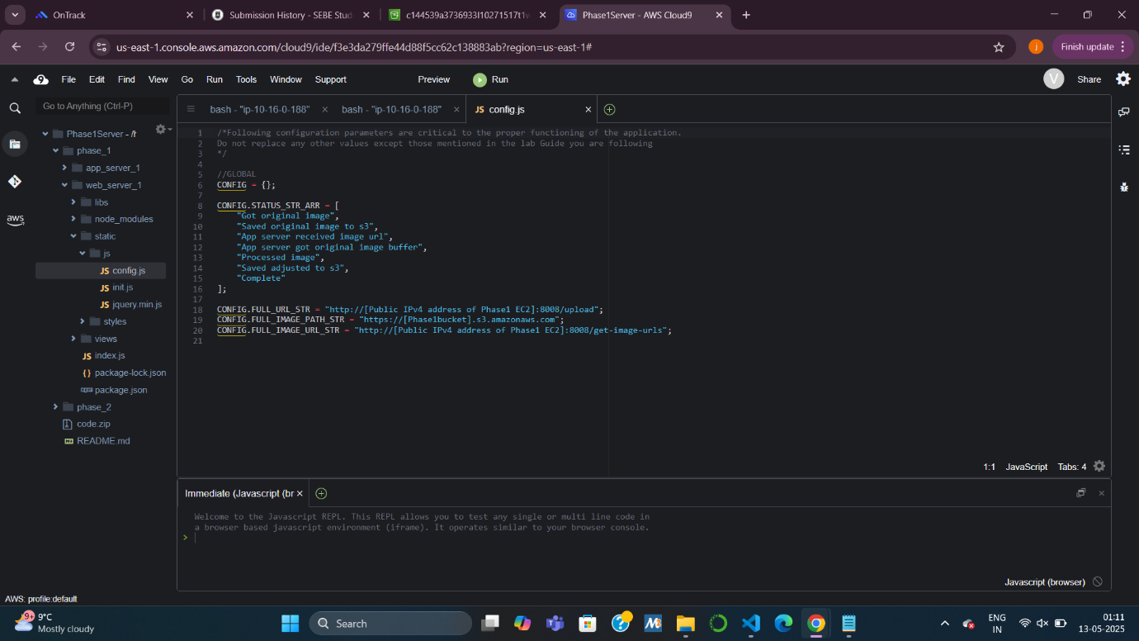

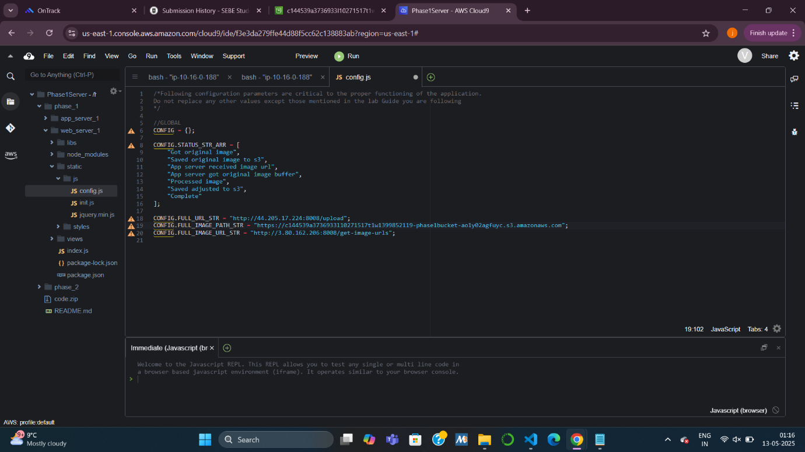

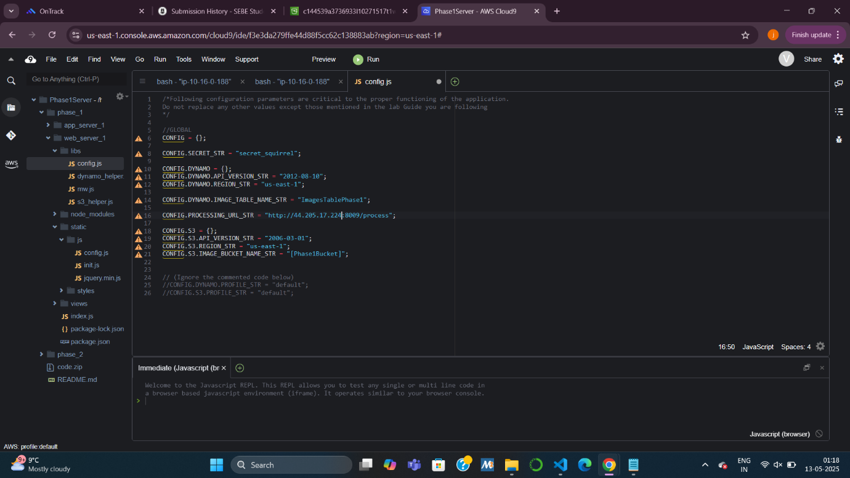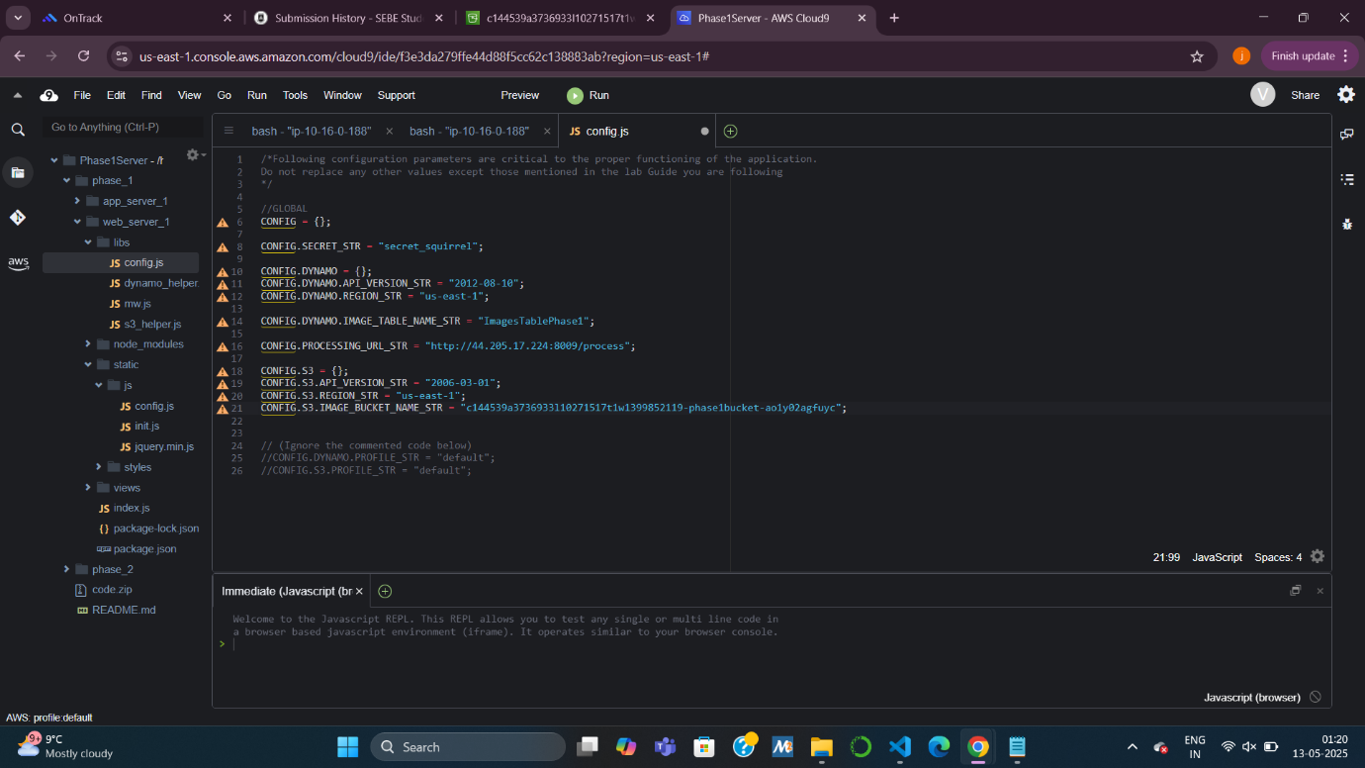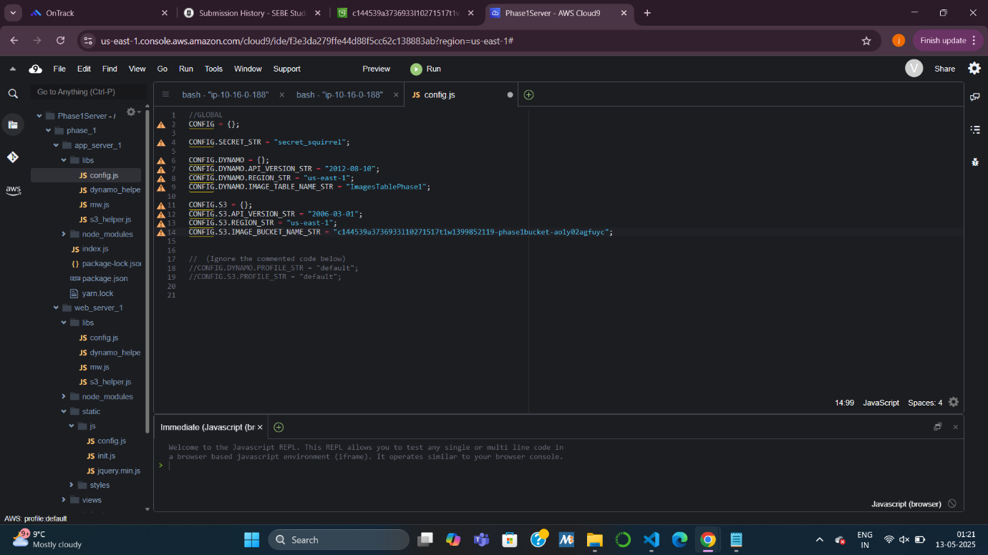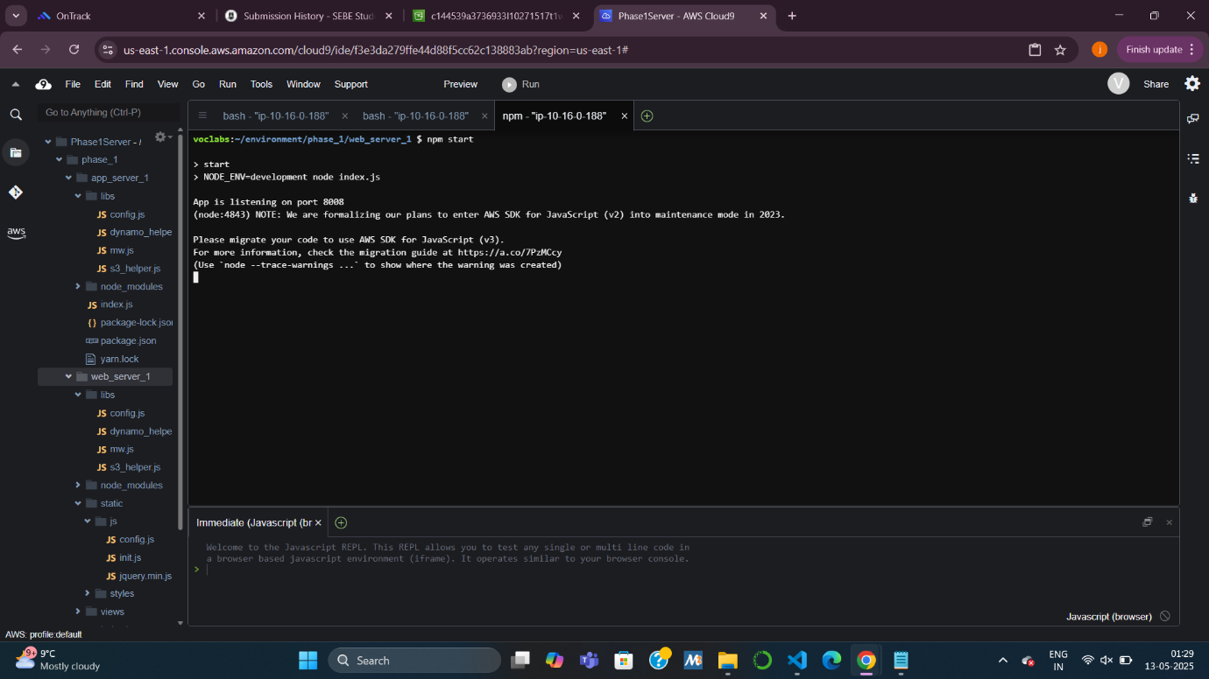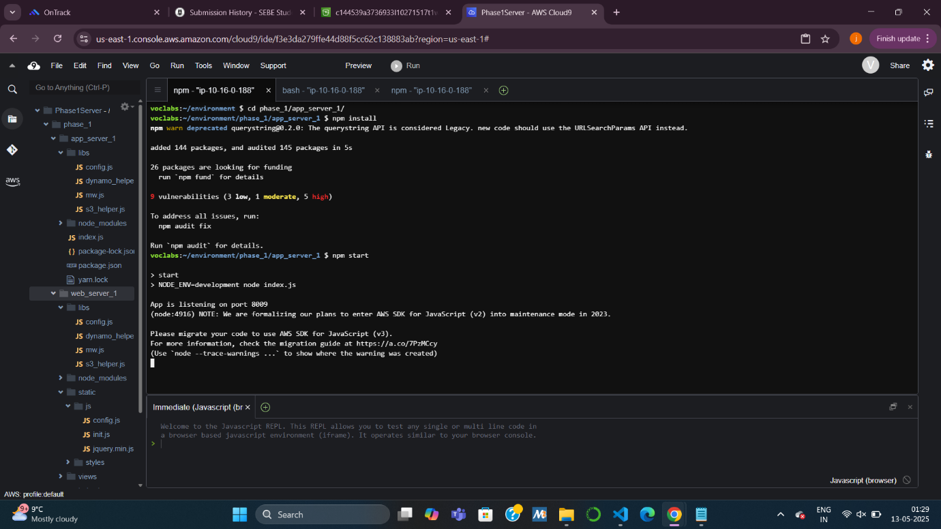

**Task 2: Testing the Application**

* Open the web app in a browser using the EC2’s public IP and port 8008.
* Upload images and observe them getting processed and displayed.
* Try image deletion and view how the tightly coupled components interact in real time.

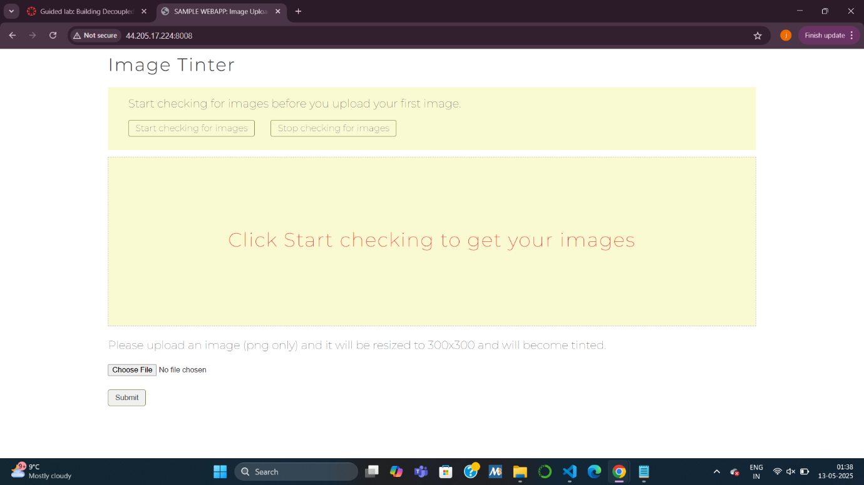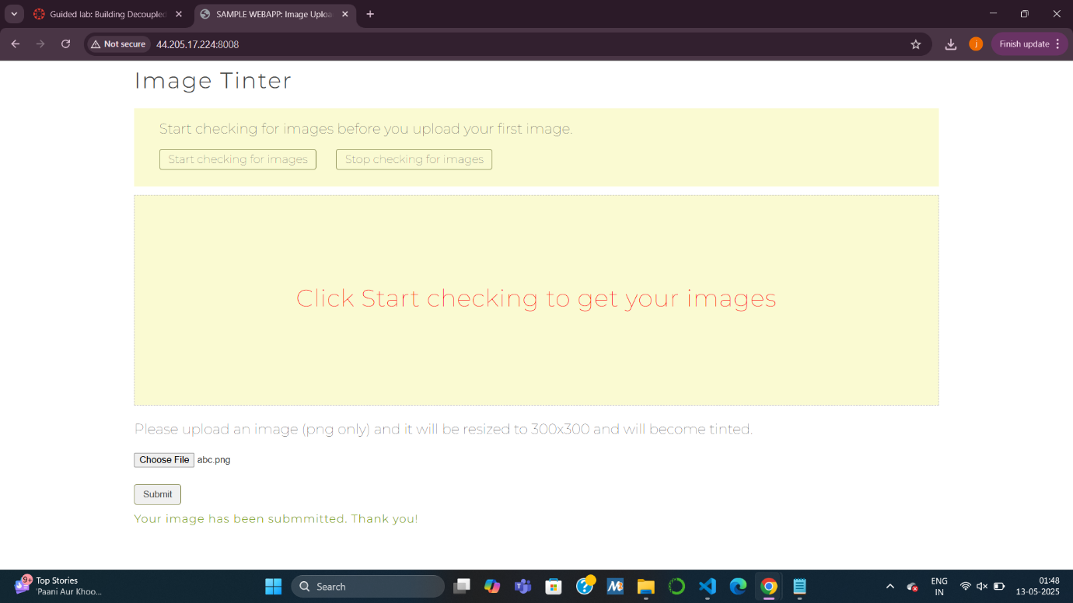

**Task 3: Installing the Application in Phase 2**

**3.1 Logging in to Cloud9**

* Access the new Phase 2 Cloud9 IDE and disable temporary credentials like before.

**3.2 Downloading Files and Installing the App**

* Download and install the application in the **phase_2** directory for both web and app servers.

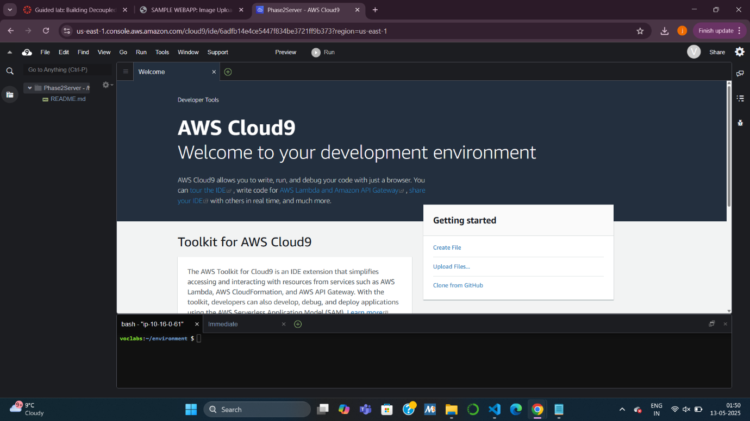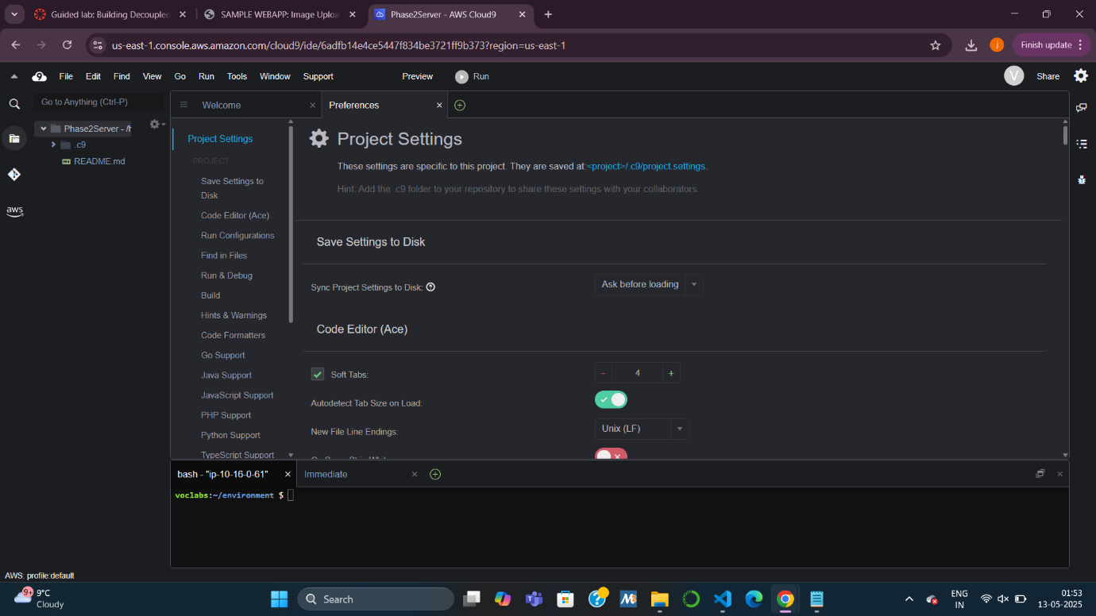

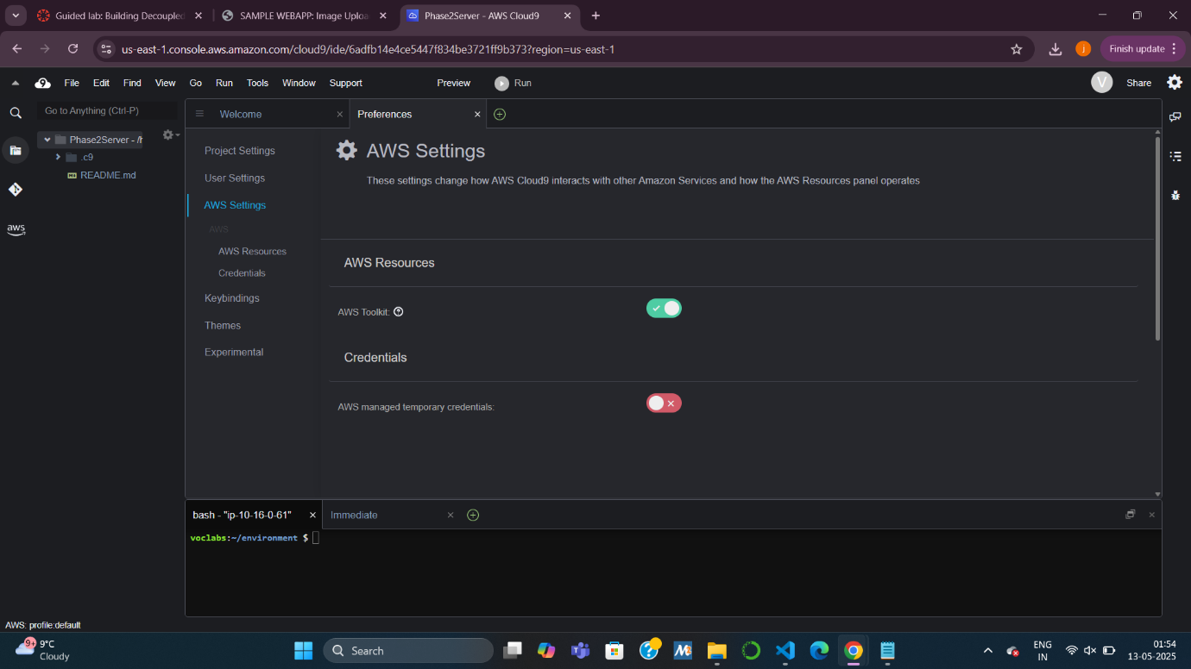

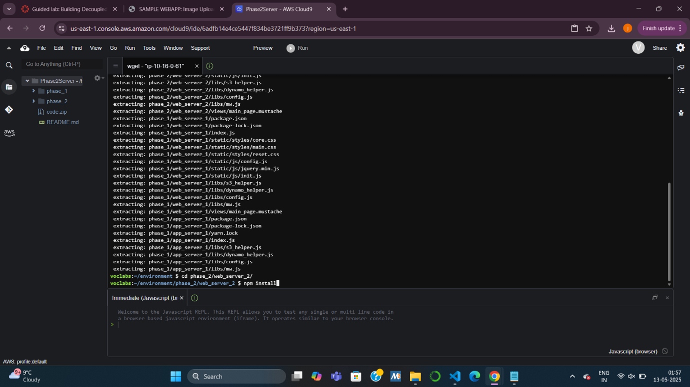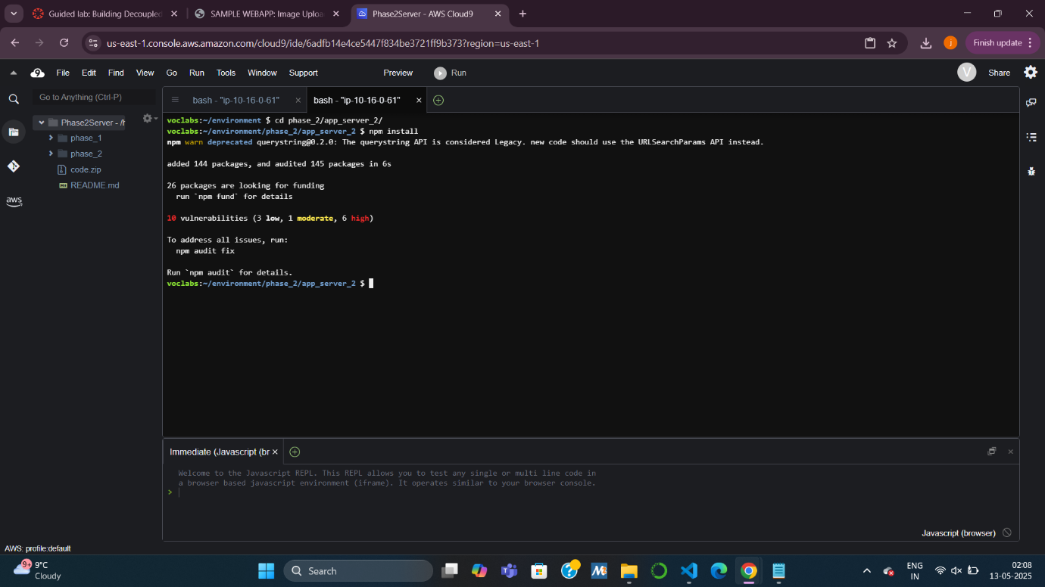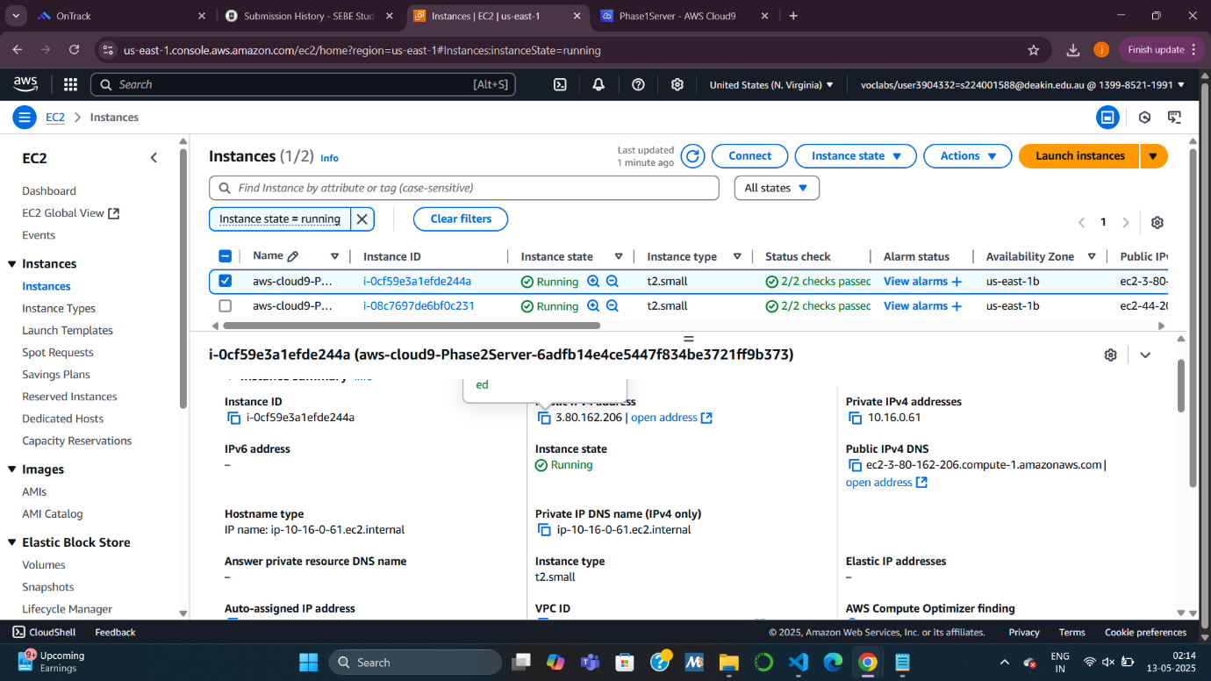**Task 4: Configuring Amazon SQS**

* Create an **SQS queue** named ImageApp to hold messages that trigger image processing.

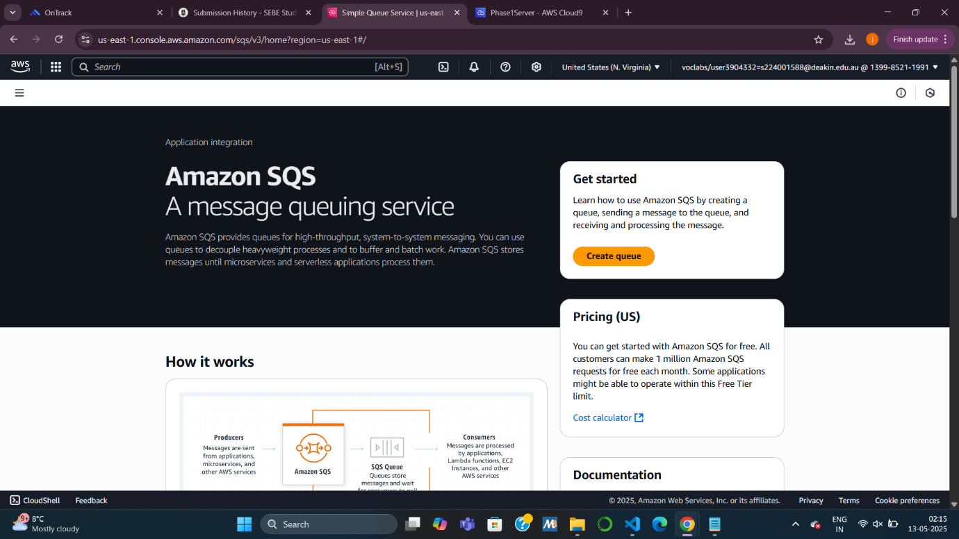

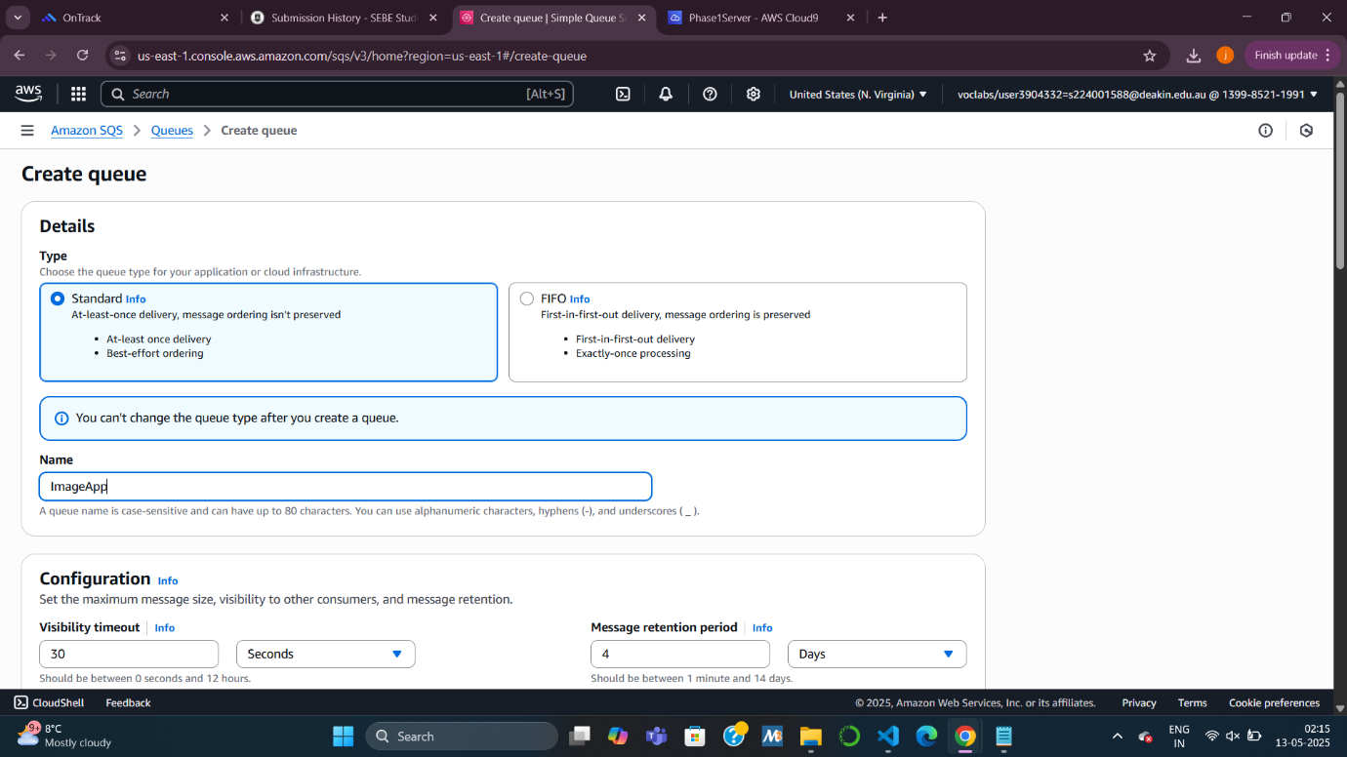

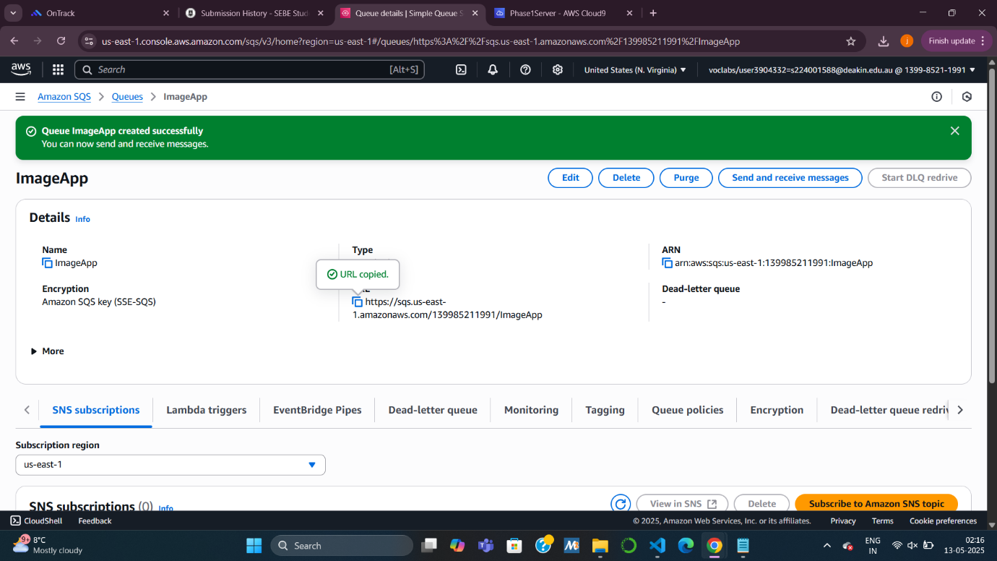**Task 5: Configuring Amazon SNS**

* Create an **SNS topic** uploadnotification and attach a policy to allow S3 to publish messages to it upon new uploads.

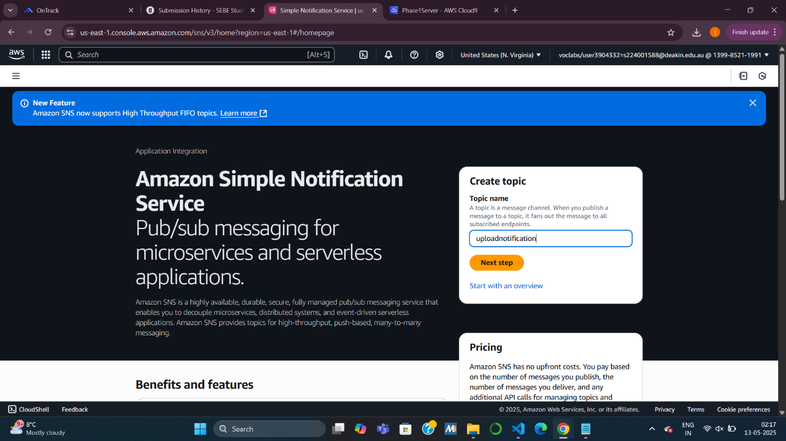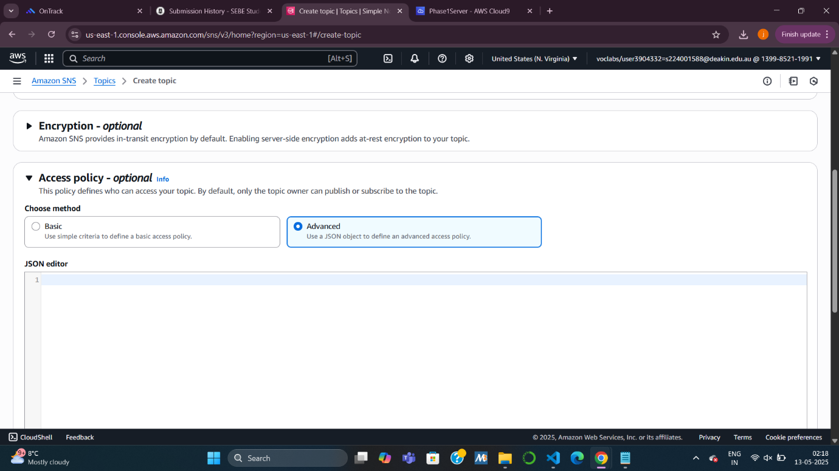

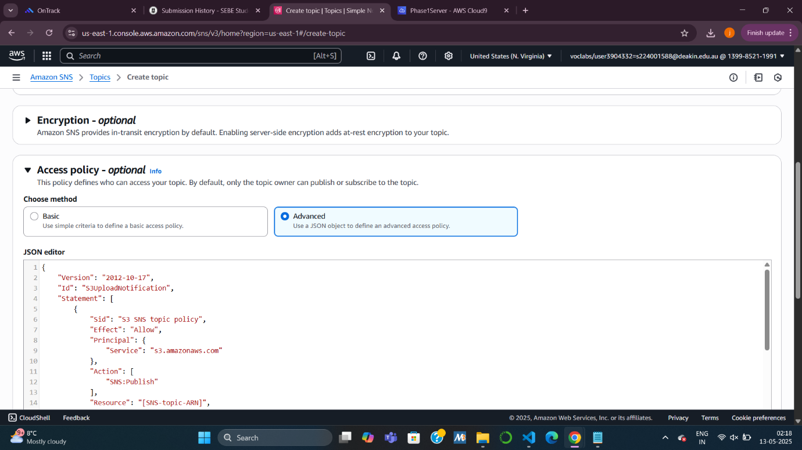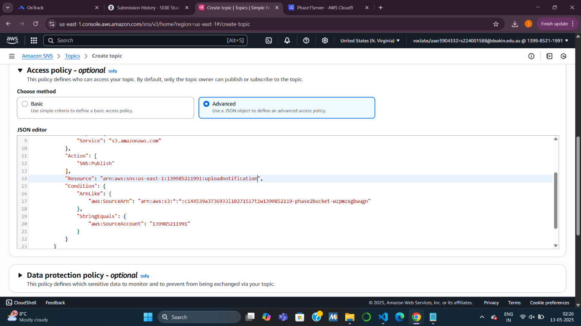

**Task 6: Configuring S3 Bucket Permissions & Event Notification**

* **Unblock public access** and update **bucket policy** with your IP.
* Create an **event notification** to trigger the uploadnotification SNS topic on object creation.

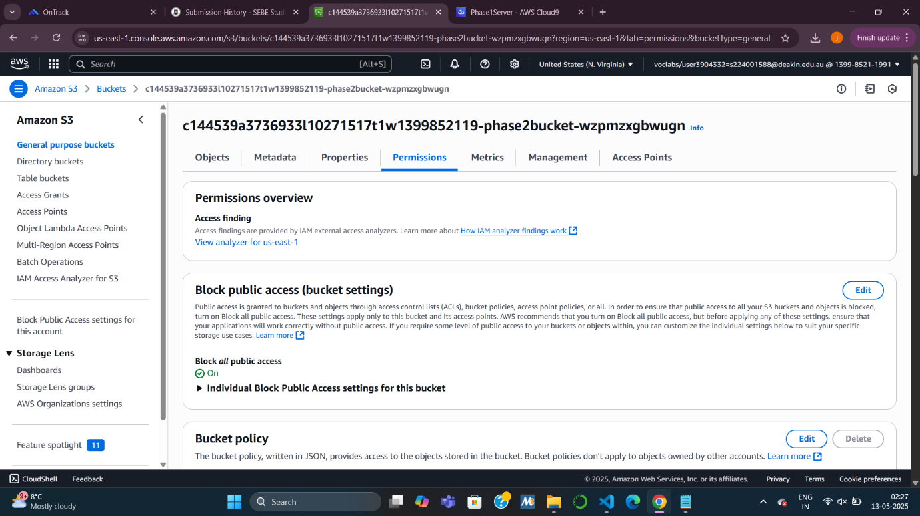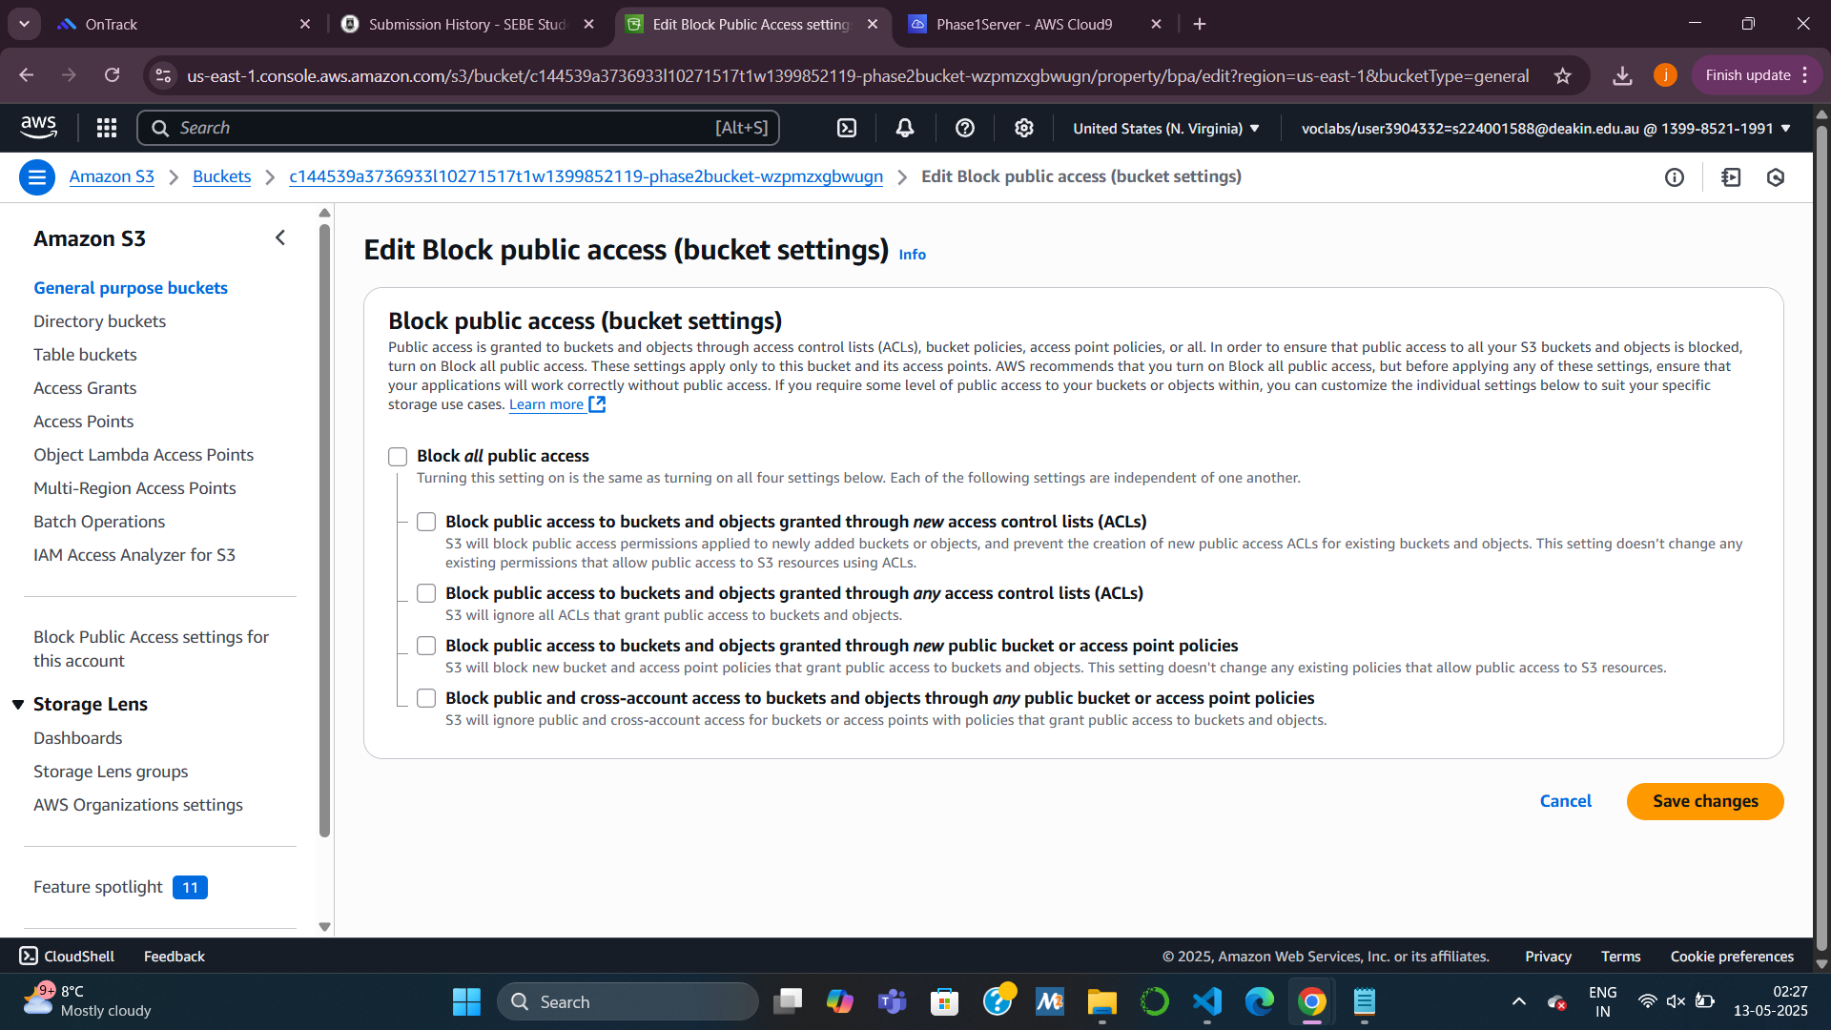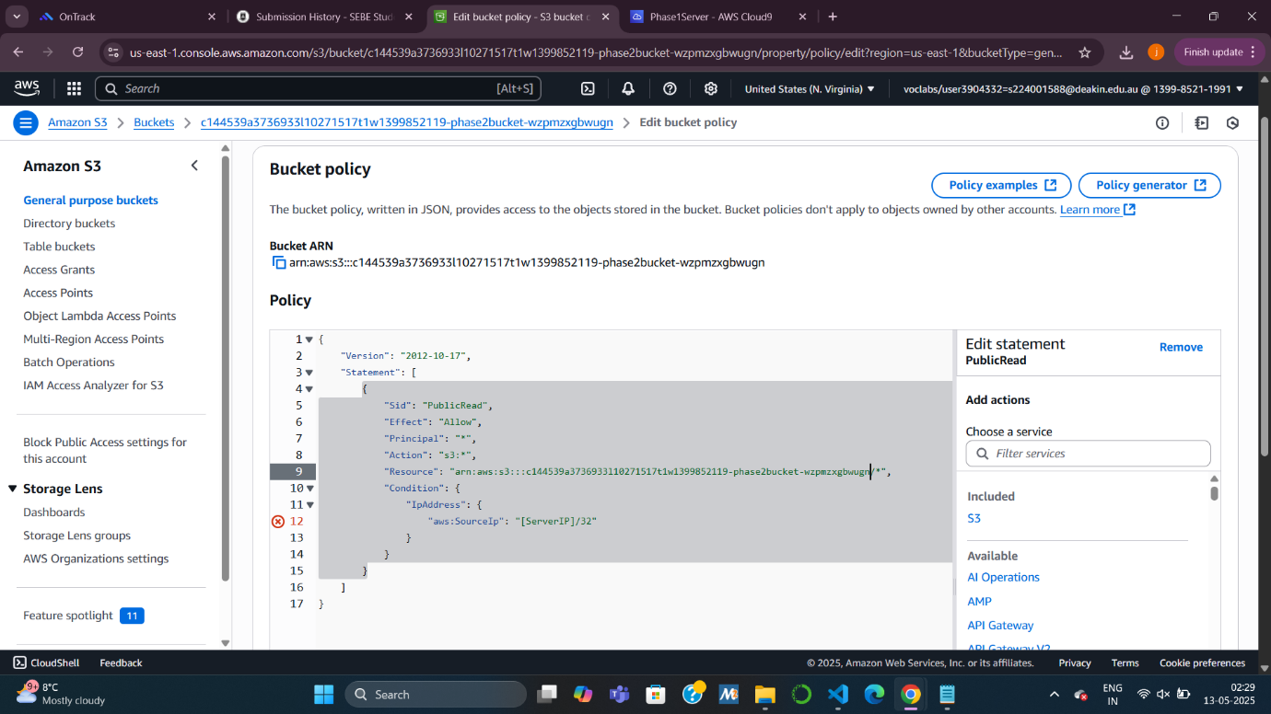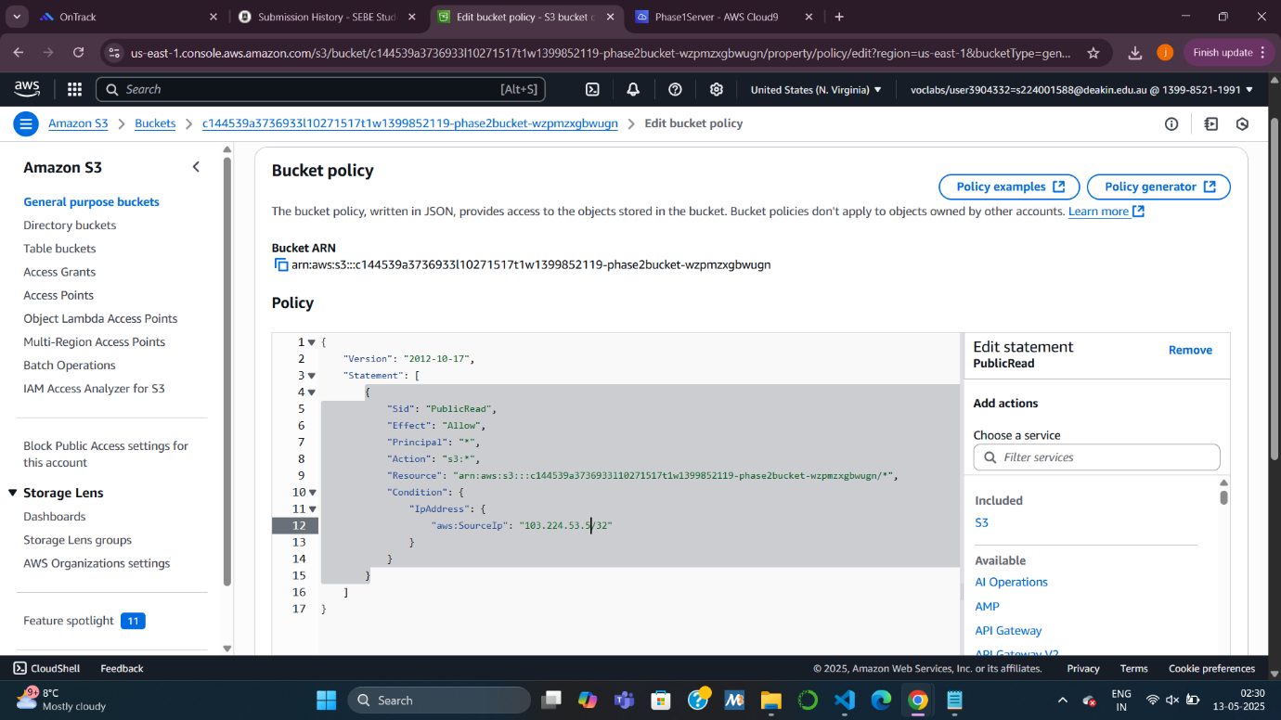

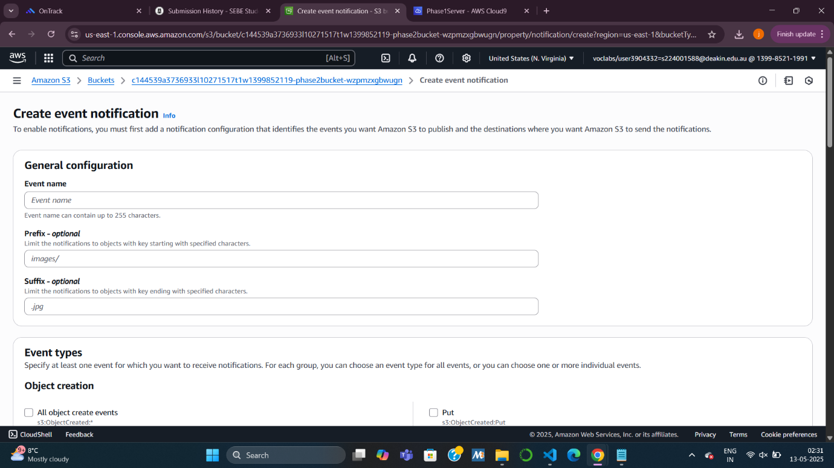

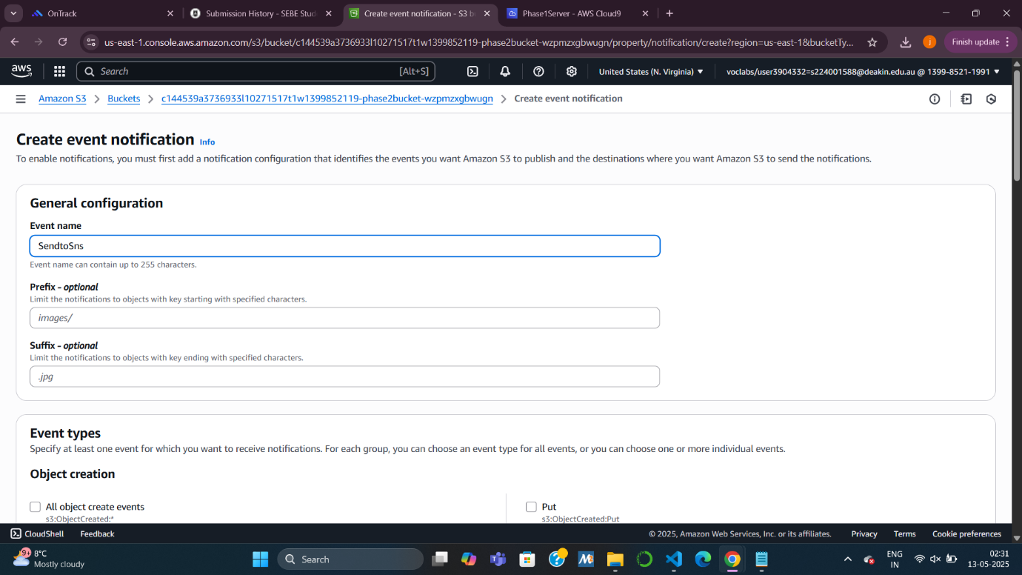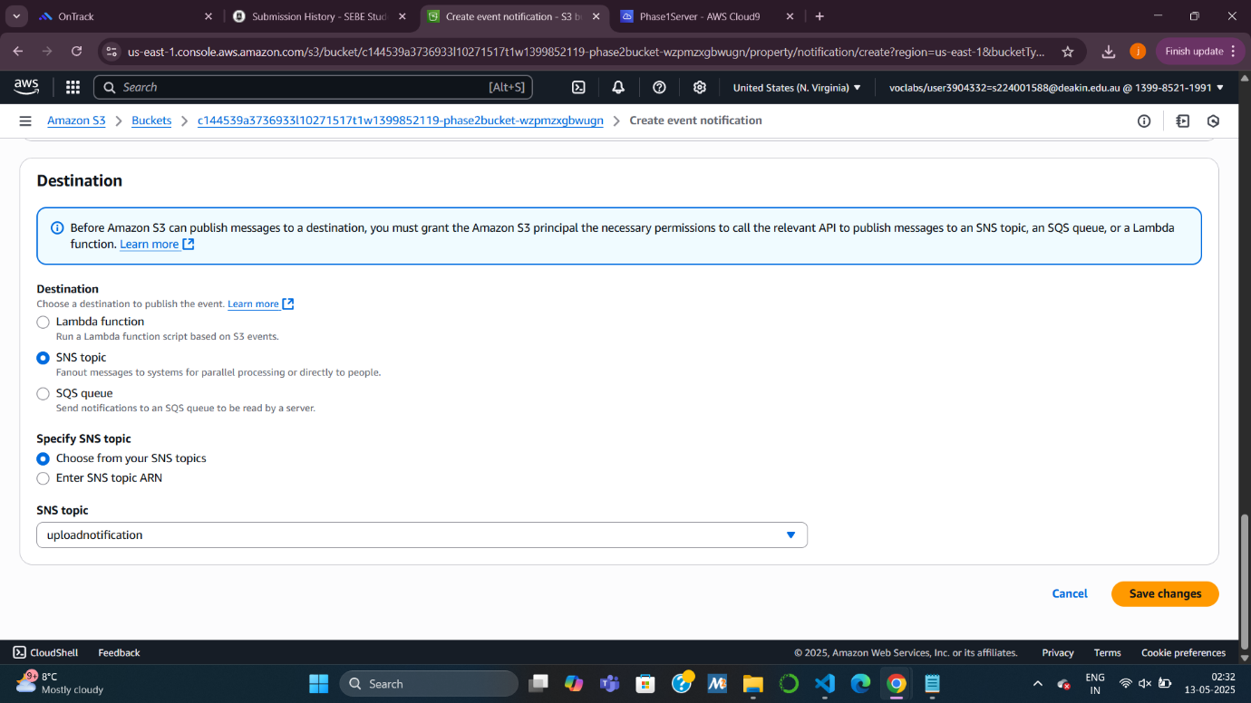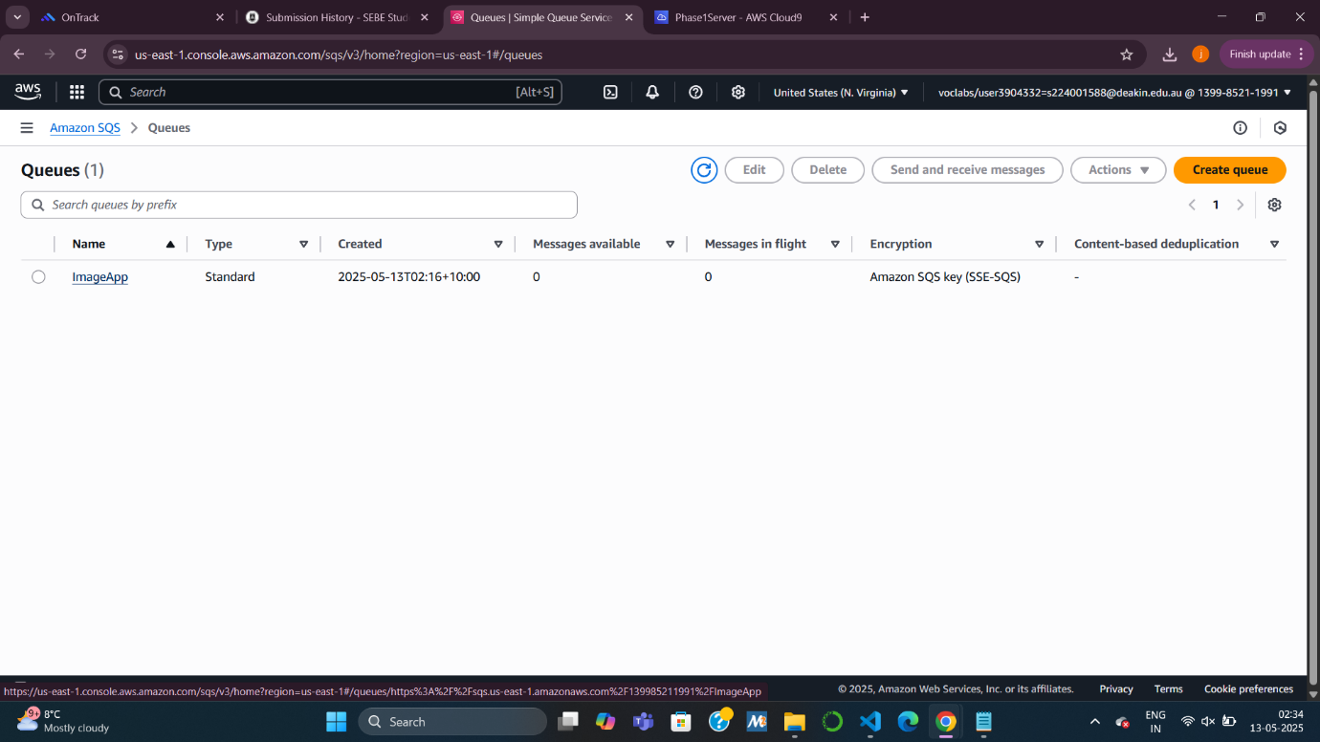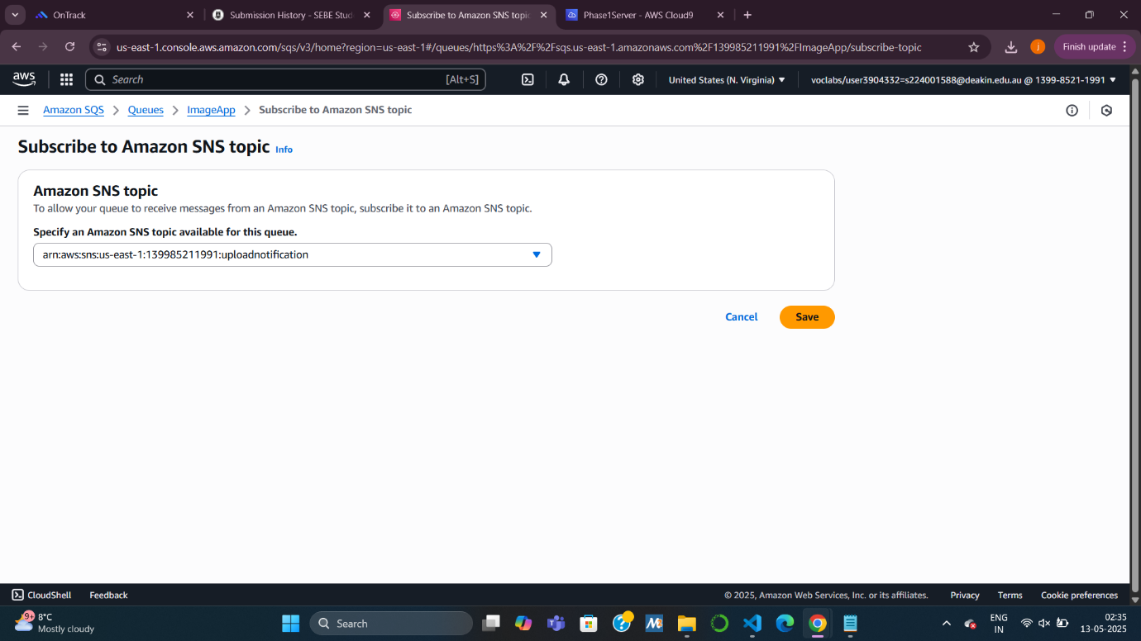**Task 7: Creating SNS Subscriptions**

**7.1 SQS Subscription**

* Subscribe the ImageApp queue to the uploadnotification SNS topic.

**7.2 Email Subscription**

* Create an **email subscription** to receive alerts on new uploads.
* Confirm it via the email link.

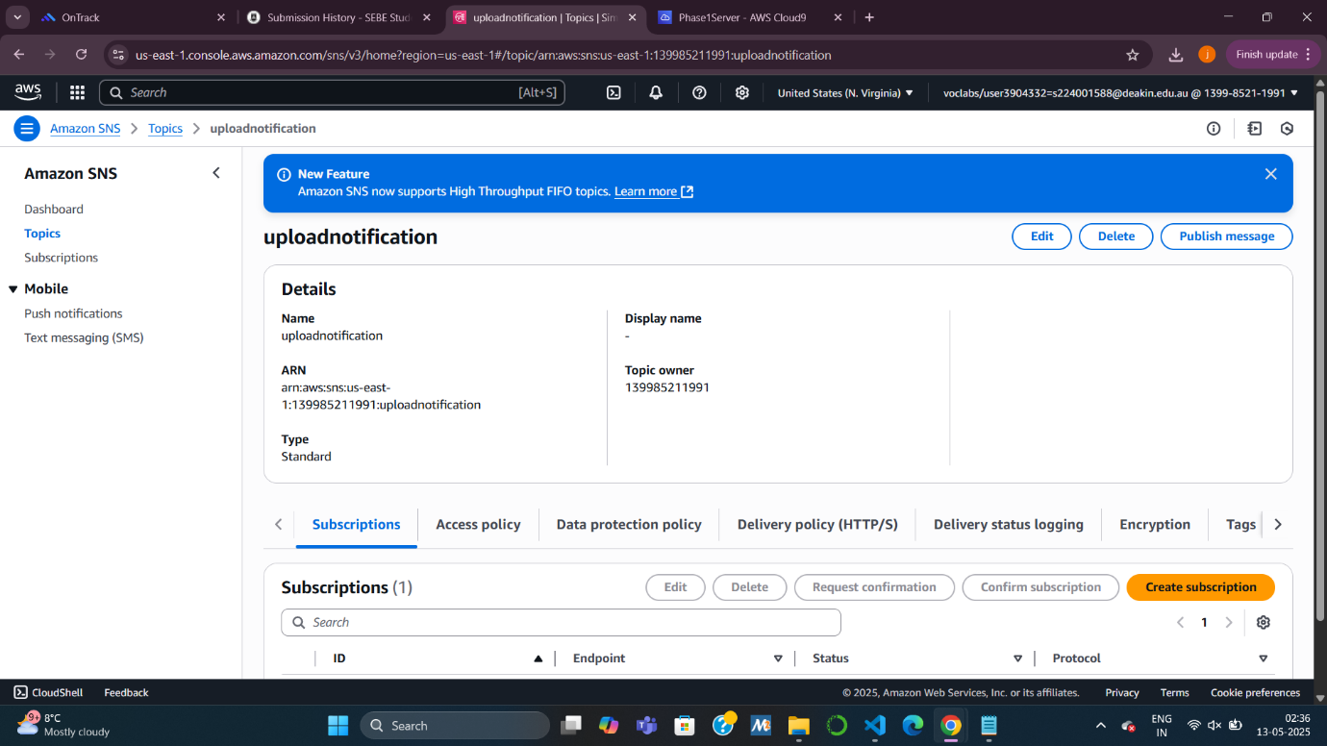

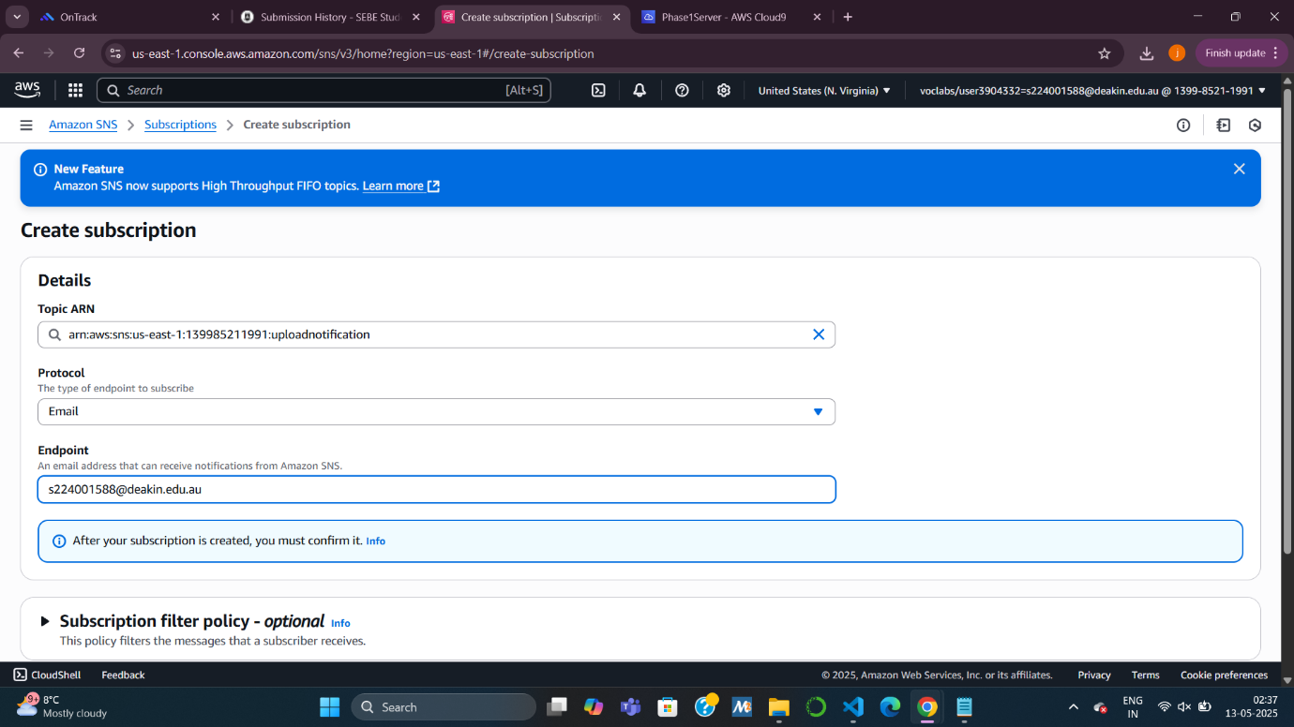

**Task 8: Configuring Parameters and Starting the App**

* Edit and update config files in:
  + **Browser tier**
  + **Web tier**
  + **App server tier**
* Add real values for public IP, bucket name, and SQS URL.
* Start the web server (port **8007**) and app server (port **8010**).

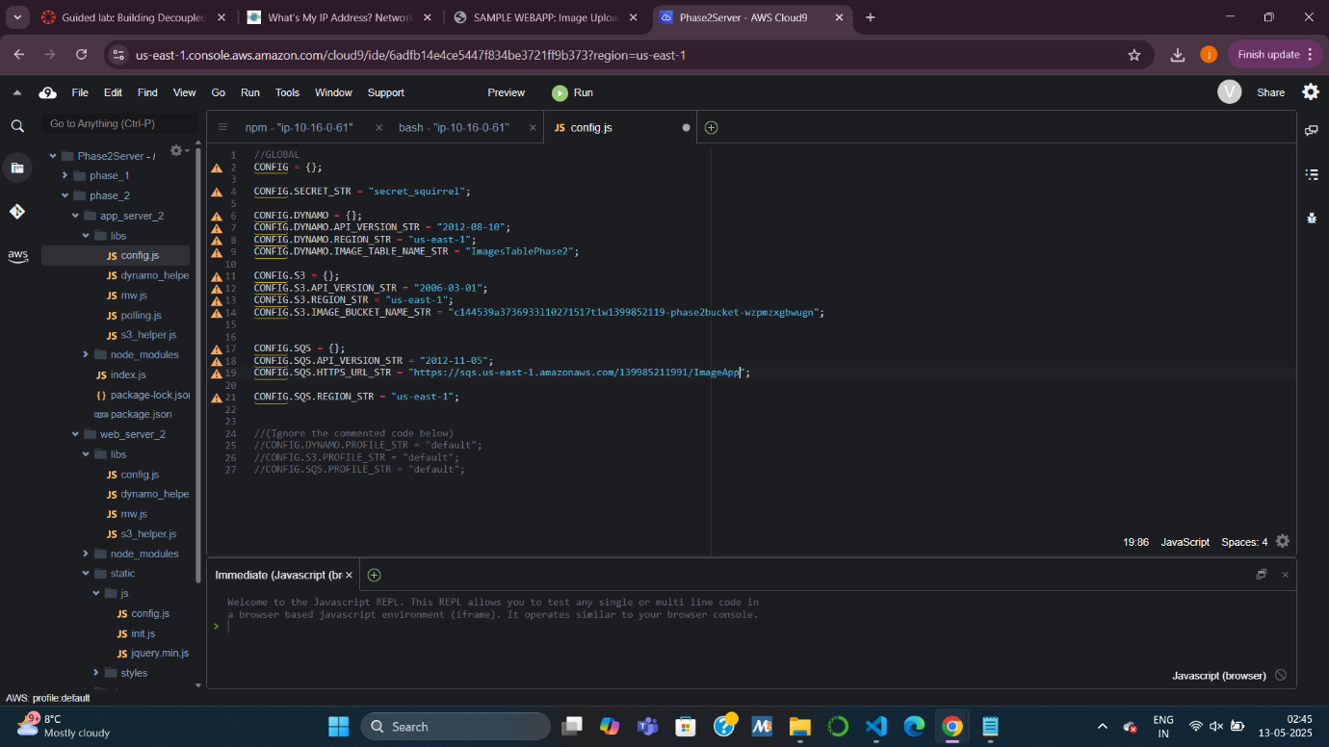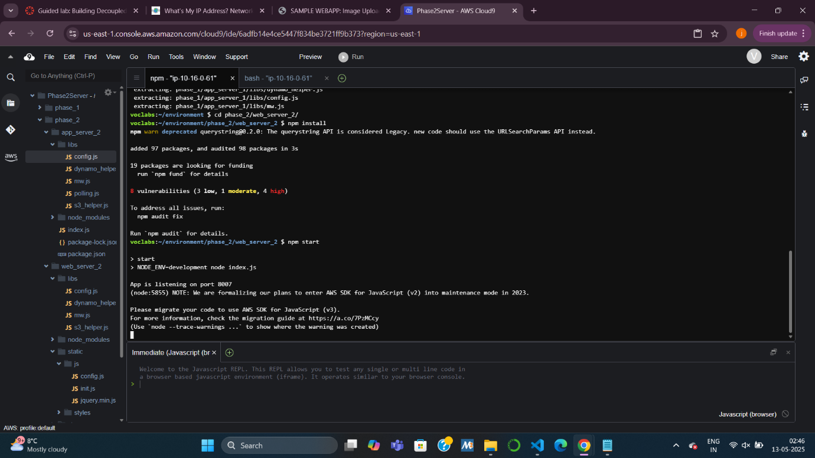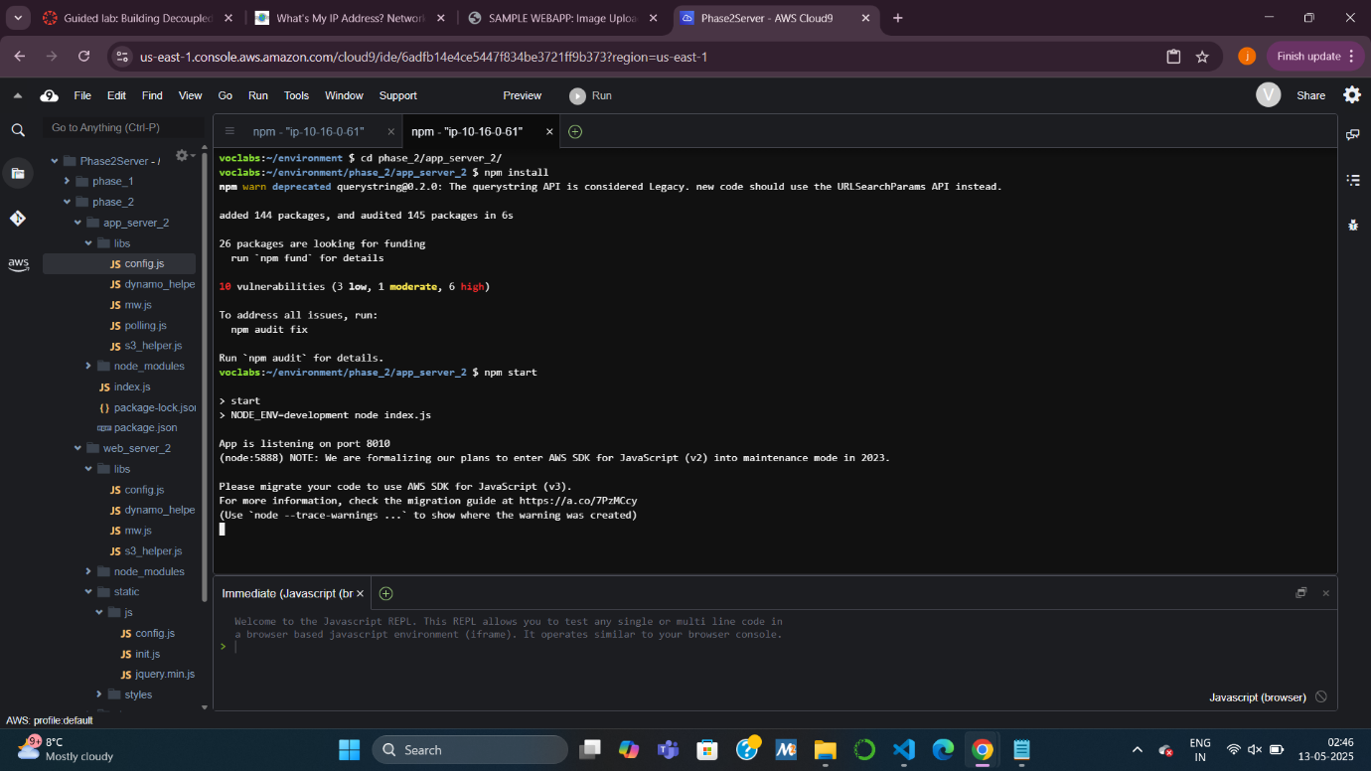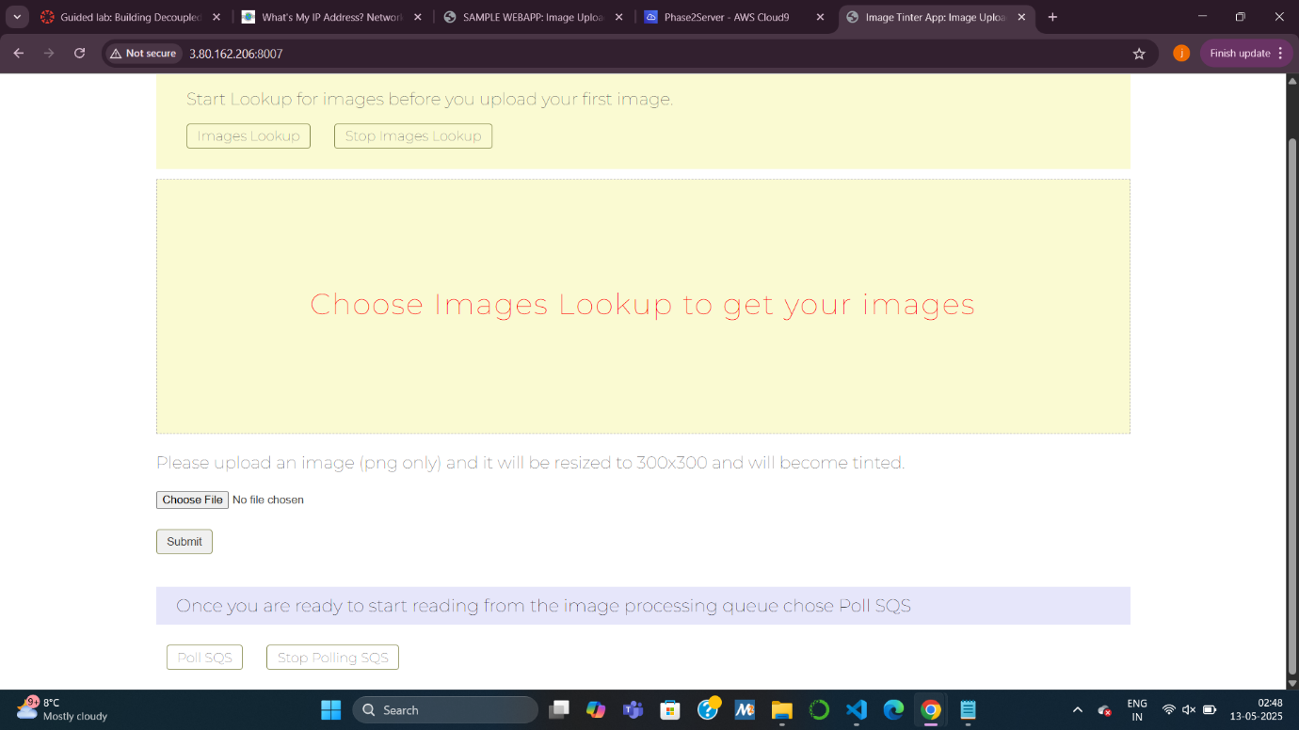

**Task 9: Testing the Decoupled App**

* Access the app via browser and upload images.
* Observe delayed processing (via SQS polling) and receive email alerts when uploads and processing happen.
* Shows loose coupling: servers act independently, making the system more fault-tolerant.

